AI vs ML vs Deep Learning

1. **Artificial Intelligence (AI):** This is the biggest and oldest idea. The goal of AI is to create smart applications that can perform tasks on their own without human intervention.
   * **Examples:** Netflix recommending movies, self-driving cars, and Amazon suggesting products.
2. **Machine Learning (ML):** This is a *part* of AI. ML uses statistical tools to let computers learn from data. It's used to analyze data, find patterns, and make predictions or forecasts.
   * **Example:** A weather app that learns from past weather data to predict tomorrow's temperature.
3. **Deep Learning (DL):** This is a *part* of Machine Learning. Deep Learning is a very popular and powerful technique that tries to make machines learn in the same way humans do, by mimicking the structure of the human brain. It does this using something called **multi-layered neural networks**.

**What Will Be Covered in the Deep Learning Series?**

The video outlines the main topics that will be taught, which are different types of neural networks for different kinds of problems:

1. **Artificial Neural Networks (ANN):**
   * This is the fundamental type of neural network.
   * **Use Cases:** Solving standard problems like classifying data into categories (e.g., "is this email spam or not?") or regression (e.g., "predicting the price of a house").
2. **Convolutional Neural Networks (CNN):**
   * This is a special type of network designed for **Computer Vision**.
   * **Use Cases:** It works exceptionally well when the input is an **image or a video**. It's used for tasks like image classification, object detection (finding objects in a picture with techniques like **YOLO** and R-CNN), and image segmentation.
3. **Recurrent Neural Networks (RNN):**

This network is designed to work with **sequences of data**, where the order matters.

* **Use Cases:**
  + **Natural Language Processing (NLP):** Understanding and processing text data (e.g., language translation, sentiment analysis).
  + **Time Series Analysis:** Forecasting future values based on past data (e.g., predicting stock prices or future sales).
* The series will also cover more advanced versions of RNNs like **LSTM, GRU, Transformers, and BERT**, which are very powerful for language-related tasks.

**Perceptron**

A **Perceptron** is the simplest type of neural network. You can think of it as a single building block of a larger, more complex brain-like network. It's mainly used for **binary classification**, which means it helps make "yes" or "no" decisions.

**How a Perceptron Works**

A Perceptron has a simple structure and follows a two-step process:

**1. The Structure**

* **Inputs:** These are the pieces of information you give the Perceptron. In our example, the inputs would be the student's IQ and study hours.
* **Weights:** Each input is assigned a "weight," which represents its importance. For instance, study hours might be more important than IQ for passing an exam, so it would get a higher weight. The goal of "training" the Perceptron is to find the best weights.
* **Bias:** This is an extra value that is added to help the model make better predictions. It's like a small adjustment that can shift the outcome one way or another. If the weights are zero then processing does not happen and hence we will add bias which is a small value
* **Neuron:** This is the core processing unit where all the calculations happen.

**2. The Two-Step Process Inside the Neuron**

**1. Summation:** The Perceptron multiplies each input by its weight, adds them all up, and then adds the bias. This gives a single number, let's call it z.

z = (input1 * weight1) + (input2 * weight2) + ... + bias

This step is very similar to the equation of a straight line (y = mx + c), which is why a Perceptron is known as a **linear classifier**. It tries to separate the data by drawing a straight line.

1. **Activation Function:**

*It introduces non-linearity into the network and plays key role in activating/de-activating the neuron.* The number z is then passed through an "activation function." This function's job is to make the final decision. For a pass/fail problem, it might work like this:

* + If z is greater than a certain threshold (e.g., 0), the output is 1 (Pass).
  + If z is less than or equal to the threshold, the output is 0 (Fail).

**Training the Perceptron**

Initially, the weights are just random guesses. The Perceptron makes a prediction, and we compare it to the correct answer.

* + If the prediction is correct, the weights are good.
  + If the prediction is wrong, the model calculates the **error** and adjusts the weights slightly to try and get it right the next time.

This process is repeated over and over with all the data until the Perceptron learns the best weights to accurately separate the "pass" cases from the "fail" cases.

**Single-Layer Perceptron: Good but Limited**

A **single-layer perceptron** is the most basic type of neural network.

* **What it's good at:** It's great for solving simple problems where you can separate two groups of data with a single straight line. This is called a **linearly separable problem**. Imagine you have red dots and blue dots on a graph, and you can draw one line to keep all the red dots on one side and all the blue dots on the other. A single-layer perceptron can learn to draw that line.
* **How it learns:** It makes a guess (this is called "feed-forward"). If the guess is wrong, it adjusts its internal "weights" and tries again. However, the way it adjusts these weights is not very efficient.

**The Big Limitation**

The main problem is that most real-world problems are not that simple. You often have data that can't be separated by a single straight line. For example, you might have a cluster of red dots completely surrounded by blue dots. A single-layer perceptron **cannot** solve this kind of **non-linear problem**.

**Multi-Layer Perceptron: The Solution**

This is where the **multi-layer perceptron** (also known as an Artificial Neural Network or ANN) comes in. It's a more advanced network that can solve these complex, non-linear problems.

It does this by introducing several powerful new techniques:

1. **Backward Propagation (Backpropagation):** This is the most important invention. Instead of just guessing how to fix its mistakes, the network uses the error to intelligently calculate exactly how to adjust its weights to get better. It's a much more efficient and powerful way to learn.
2. **Loss Functions:** This is a way to measure exactly *how wrong* the network's prediction was. A bigger error means the network needs to make a bigger adjustment.
3. **Optimizers:** These are smart algorithms that use the information from the loss function and backpropagation to update the weights in the best possible way, helping the network learn much faster.

In short, while a **single-layer perceptron** can only solve simple problems by drawing straight lines, a **multi-layer perceptron** uses advanced techniques like backpropagation and optimizers to learn complex patterns and solve much more difficult, real-world problems.

**Artificial Neural network:**

Imagine you want to teach a computer to predict whether a student will pass or fail an exam based on their IQ, study hours, and play hours. A multi-layer neural network can learn to do this.

The learning process happens in a cycle with two main phases: **Forward Propagation** (making a guess) and **Backward Propagation** (learning from the mistake).

**1. Forward Propagation: Making a Guess**

This is the process of the information moving forward through the network to make a prediction.

* **Input:** You feed the network the data for one student (e.g., IQ=95, Study Hours=4, Play Hours=4).
* **Hidden Layers:** This data passes through one or more "hidden layers." Each layer contains "neurons."
* **Inside Each Neuron:**
  1. **Weighted Sum:** The neuron takes its inputs, multiplies each one by a "weight" (which represents its importance), and adds them all up with a special number called a "bias." Initially, all these weights are just random guesses.
  2. **Activation Function:** The result is then passed through an **activation function** (like a Sigmoid function). This function acts like a dimmer switch, converting the result into a value between 0 and 1. This decides how "activated" or important the neuron's output is.

**Final Output:** The output from the last neuron is the network's final prediction. For our student, the network might predict 0.51. This is its guess.

**2. Calculating the Error (Loss Function)**

Now, the network compares its guess to the correct answer.

1. The network predicted 0.51.
2. The actual result for this student in the data was 1 (meaning "Pass").
3. The difference between the prediction (0.51) and the actual answer (1) is the **error** (or **loss**). In this case, the error is about 0.49
4. The main goal is to make this error as small as possible

**3. Backward Propagation: Learning from the Mistake**

Since the error is large, the network needs to adjust its internal weights to make a better guess next time. This is where backward propagation comes in.

* **Working Backwards:** The network takes the error and works its way *backward* from the output layer to the input layer.
* **Assigning Blame:** It figures out how much each weight and bias contributed to the final error. Weights that had a bigger impact on the wrong answer will need a bigger adjustment.
* **Updating the Weights:** Using an **optimizer** (a tool that helps reduce the error efficiently), the network slightly adjusts all the weights. For example, it might increase some weights and decrease others to nudge the final prediction closer to the correct answer.

**The Learning Cycle**

This entire process—**Forward Propagation**, **Calculating Loss**, and **Backward Propagation**—is repeated for every student in your dataset, over and over again.

344. Backward Propagation and Weight updation:

Imagine you're teaching a computer to predict an outcome (like whether a student will pass an exam) based on some inputs (like IQ, study hours, and play hours). Here’s how it learns, broken down into simple steps:

**1. The Setup (The "Brain")**

* You build a simple network with an input layer (for the data), a hidden layer (for thinking), and an output layer (for the final prediction).
* Connections between these layers have "weights," which are just numbers that determine how much importance to give to each input. Initially, these weights are random guesses.

**2. The First Guess (Forward Propagation)**

* The network takes the inputs (IQ, study hours, etc.).
* It multiplies them by the weights, adds another number called a "bias," and passes them through the layers.
* It makes a final prediction. Since the weights were random, this first guess is likely wrong.

**3. Measuring the Error (Loss Function)**

* The network compares its prediction to the correct answer. The difference between the two is the "error" or "loss."
* The goal is to make this error as small as possible. A big error means the network needs to learn better.

**4. Learning from Mistakes (Backward Propagation & Gradient Descent)** This is the most important part. The network now has to adjust its weights to make a better guess next time.

* **The Goal:** Find the perfect set of weights that results in the lowest possible error. Think of this like trying to find the lowest point in a valley. This lowest point is called the **"global minima."**
* **The Formula for Learning:** The network uses a special formula to update each weight: new_weight = old_weight - (learning_rate * slope)

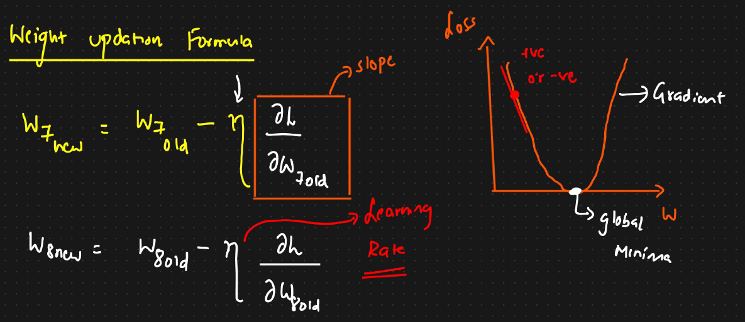

Slope is calculated between weights and loss function and in order to reduce the loss function we will use some optimiser and in this case we will use **Gradient decent optimizer** and we need to plot graph between weights and loss function to attain Global minima. Once we reach global minima, we no need to update the weights

Optimizer role : It is used to reduce the loss value and this can be attained by updating the weights

**Slope 🡪 Unit moment in x-axis what is the unit moment in y-axis**

* **Breaking Down the Formula:**
  + slope: This tells the network which direction to go. If the current weight is on the left side of the valley's bottom, the slope is negative, and the formula tells the weight to *increase* (move right). If it's on the right side, the slope is positive, and the formula tells the weight to *decrease* (move left).
  + learning_rate: This is a small number that controls *how big* of a step to take. A small learning rate means taking careful, small steps towards the bottom of the valley, which is safer. A large learning rate is like taking giant leaps, and you might overshoot the bottom entirely.

**5. Repeat!** The network repeats this process—making a guess, calculating the error, and updating the weights—over and over. With each cycle, the weights get a little bit better, the error gets smaller, and the network's predictions become more accurate.

345. Chain rule of derivative:

**2. What is the Chain Rule? A Simple Example**

The chain rule helps us find the effect of one variable on another when they are connected through a series of intermediate steps.

The text first uses a simple network: **Input Layer → Hidden Layer (1 neuron) → Output Layer (1 neuron)**.

* Let's say we want to update w4, a weight connecting the hidden layer to the output layer.
* The final **Loss (L)** is directly affected by the final **output (o2)**.
* The final **output (o2)** is directly affected by the weight **w4**.

To find the effect of w4 on the loss (dL/dw4), we can't calculate it in one go. We use the chain rule to break it down:

dL/dw4 = (How much the Loss changes when o2 changes) × (How much o2 changes when w4 changes)

In mathematical terms, this is: dL/dw4 = (dL/do2) * (do2/dw4)

This "chain" of effects allows the network to precisely calculate the gradient for w4.

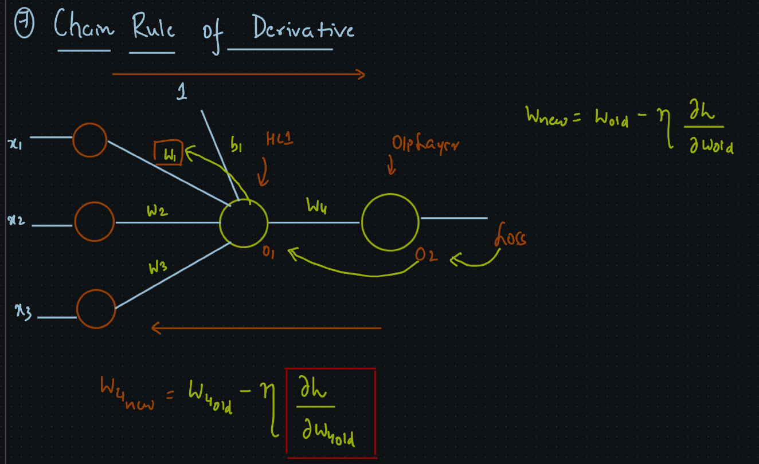

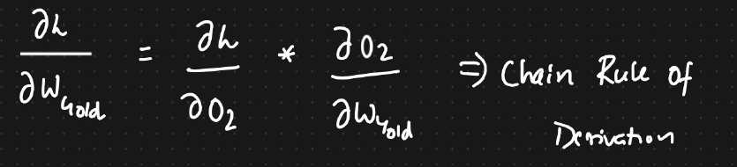

W.r.t w1

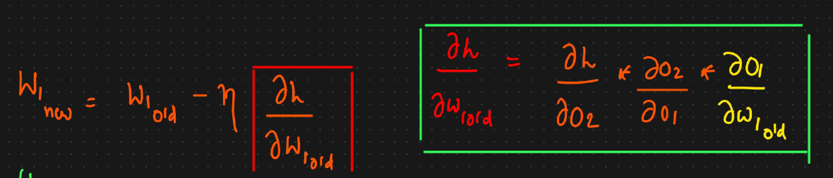

**3. A Deeper Example: Updating a Weight in an Early Layer**

Now, what if we want to update w1, a weight in an earlier layer? The chain of influence is longer.

* The **Loss (L)** depends on the final **output (o2)**.
* The final **output (o2)** depends on the output of the hidden neuron **(o1)**.
* The hidden neuron's **output (o1)** depends on the weight **w1**.

To find the total effect of w1 on the loss (dL/dw1), we multiply the effects along the entire chain:

dL/dw1 = (Effect of o2 on L) × (Effect of o1 on o2) × (Effect of w1 on o1)

In mathematical terms: dL/dw1 = (dL/do2) * (do2/do1) * (do1/dw1)

This shows how the error from the very end of the network can be "propagated" backward to update weights at the very beginning.

**4. The Most Complex Case: Multiple Paths of Influence**

The final example in the text shows a deeper network where a single weight can influence the final error through **multiple paths**.

The network is: **Input → Hidden Layer 1 (1 neuron) → Hidden Layer 2 (2 neurons) → Output Layer (1 neuron)**

Let's say we want to update w1. This weight is connected to the neuron in the first hidden layer (output o11). From there, the signal splits and goes to *both* neurons in the second hidden layer (o21 and o22), which then combine to produce the final output (o31) and the final error.

* **Path 1:** w1 → o11 → o21 → o31 → Loss
* **Path 2:** w1 → o11 → o22 → o31 → Loss

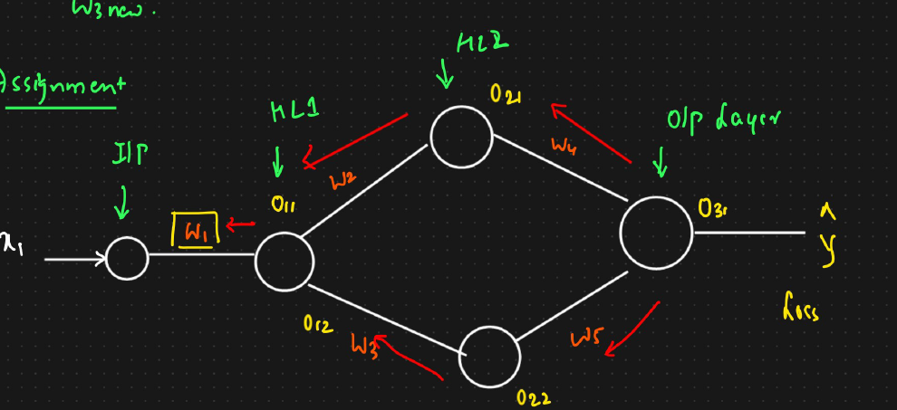

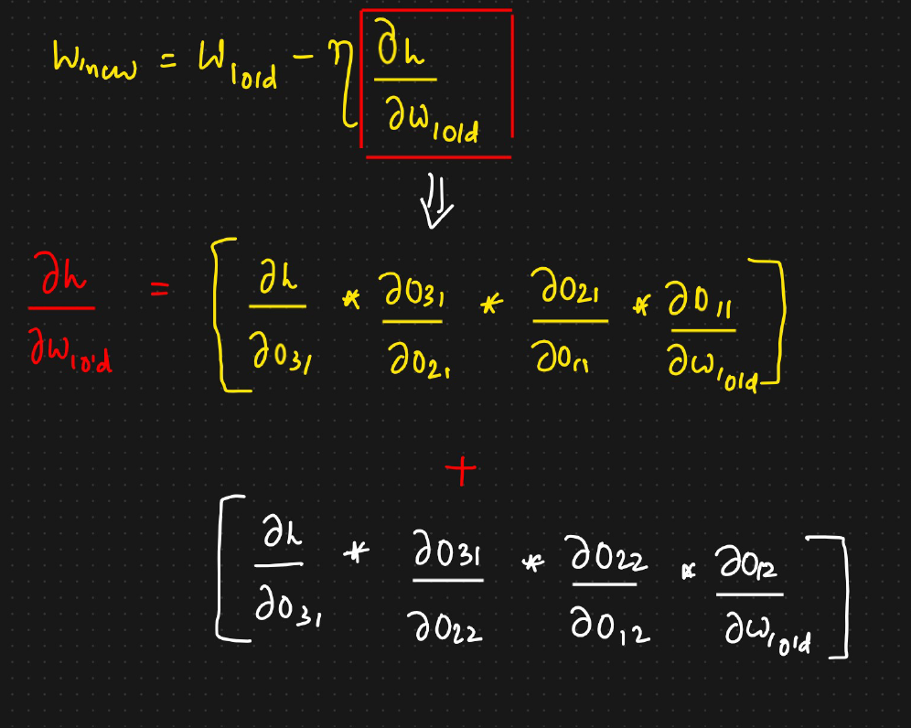

To calculate the total "blame" or contribution of w1 to the final error, the network must consider both paths. The chain rule states that you must:

1. Calculate the gradient for w1 along **Path 1**.
2. Calculate the gradient for w1 along **Path 2**.
3. **Add** the gradients from both paths together.

This sum gives you the total gradient (dL/dw1), which is then used in the weight update formula. This ensures that the full impact of a weight, across all the different ways it contributes to the output, is accounted for during learning.

In summary, the chain rule is the fundamental mechanism that allows a deep learning model to efficiently calculate how much each individual weight is responsible for the final error and adjust it accordingly, even in very complex networks with many layers and connections.

346. Vanishing gradient problem and activation functions:

**Summary of "Vanishing Gradient Problem"**

The document explains a major issue in training deep neural networks called the **vanishing gradient problem**, especially when using the **sigmoid activation function**.

Here's the breakdown in simple terms:

1. **The Goal of Training:** When training a neural network, the main goal is to adjust its internal "weights" to minimize errors. This process is called **backpropagation**.
2. **How it Works (Backpropagation):** The network calculates its error at the very end and works backward through the layers to figure out how much each weight contributed to that error. It uses a calculus concept called the **chain rule** to do this.
3. **The Sigmoid Function:** In older networks, a function called "sigmoid" was popular. Its job is to take any number and squash it into a value between 0 and 1.

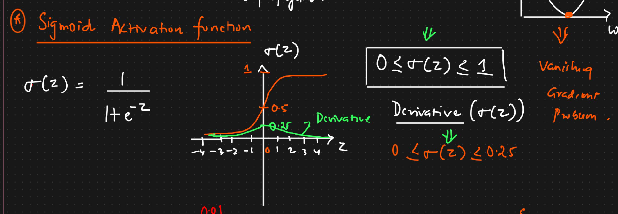

1. **The Core Problem:** The problem isn't with the sigmoid function itself, but with its **derivative** (its rate of change). The derivative of the sigmoid function is always a very small number (between 0 and 0.25).
2. **The "Vanishing" Effect:** During backpropagation, the chain rule requires multiplying these small derivative values from each layer together.
   1. Imagine multiplying many small numbers: 0.2 * 0.15 * 0.21 * 0.1 = 0.00063.
   2. The more layers you have, the more small numbers you multiply, and the final result gets incredibly tiny—it effectively "vanishes."
3. **The Consequence:** Because this final gradient value is almost zero, the network thinks the weights in the early layers have no impact on the final error. As a result, it stops updating them. The network essentially **stops learning**.
4. **The Solution:** To fix this, researchers developed better activation functions that don't have this problem, such as **ReLU** (Rectified Linear Unit), which is now the most common choice for hidden layers in neural networks.

**📈 Intuitive Understanding**

* The **sigmoid function** decides how active a neuron is.
* The **sigmoid derivative** tells us *how sensitive* that neuron’s output is to changes in input.
* During **backpropagation**, this derivative *scales the error signal* that flows backward through the network.

This means:

* If the neuron’s output is near 0 or 1 → the derivative (σ(1−σ)) is small → **small weight updates** (learning slows down).
* If the neuron’s output is near 0.5 → derivative is largest (~0.25) → **larger weight updates** → faster learning.

In short, the **vanishing gradient problem** occurs when using activation functions like sigmoid in deep networks, causing the learning signals to become too small to update the early layers, effectively halting the training process.

Because the sigmoid derivative is at most 0.25, when you have **many layers**, gradients multiply and shrink exponentially.  
This leads to **vanishing gradients** → very slow learning in deep networks.

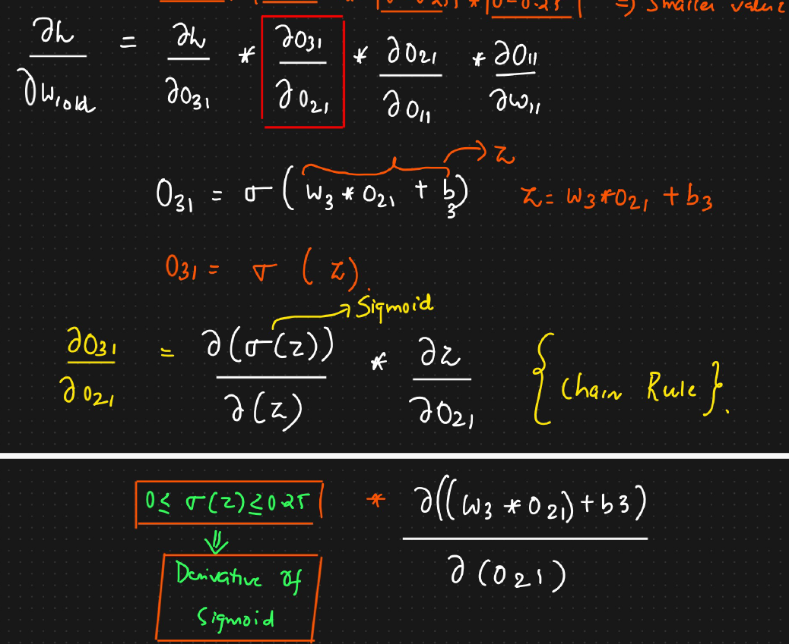

In the above example we will consider only $\frac{∂o31/}{}∂o21$ and we will split this equation

O31 = $σ\left(W3*O21+b3\right)$ and $W3*O21+b3=Z$

O31 = $σ(Z)$

$$\frac{∂\left(O31\right) }{∂\left(O21\right) }=\frac{∂\left(σ\left(z\right)\right)}{∂(z)}*\frac{∂z}{∂O21}$$

The above one is chain rule. Finding the derivatives of

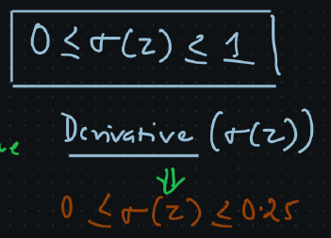

**Sigmoid Activation function ( 0 < sigmoid <1)**

**Derivative Sigmoid Activation function ( 0 < sigmoid <0.25)**

Usually weights are also initiated between 0 to 1 and hence w.r.t every derivative it will be ranging 0.25 and hence when we multiply everything we will be getting smaller values and hence this may lead getting very very small value and hence weights wont get updated and we hence convergence does not happen and hence we cannot reach to global minima and all this is happening due to sigmoid activation function and this problem is called vanishing gradient problem.

**vanishing gradient problem** Is the problem where weights ( old ) and Weights (new ) are same. To fix this problem we will have another activation function

347. Sigmod activation function:

**What is an Activation Function?** In a neural network, after combining inputs with weights and adding a bias, an activation function decides whether a neuron should "fire" or not, and how strongly.

**The Sigmoid Function:**

* It takes any input value (often called 'z') and squashes it into a range between **0 and 1**.
* Its formula is 1 / (1 + e^(-x)).
* It was very popular early in deep learning because its output can be thought of as a probability or a neuron's firing rate.

**Advantages of Sigmoid:**

* **Smooth Gradient:** It has a smooth curve, which is good for calculations.
* **Output between 0 and 1:** This is useful for normalizing outputs and making clear predictions (e.g., if output > 0.5, it's a '1'; otherwise, it's a '0').
* **Used for binary classification with clear prediction**

**Disadvantages of Sigmoid (Why it's often avoided in deep networks):**

1. **Vanishing Gradient Problem:**
   * The "gradient" is how much the output changes with respect to the input, which is crucial for updating weights during training.
   * The sigmoid's derivative (the rate of change) is very small, always between 0 and 0.25.
   * In deep networks, when these small derivatives are multiplied together (due to the chain rule in backpropagation), the values become extremely tiny.
   * This means that weights in earlier layers barely get updated, making the network learn very slowly or stop learning altogether.
2. **Not Zero-Centered Output:**
   * The output of sigmoid is always positive (between 0 and 1). It doesn't center around zero.
   * **This can make weight updates less efficient, as it can lead to "zig-zagging" paths during optimization**. Imagine trying to find the bottom of a valley, but you can only move in directions that are always uphill or always downhill, not both.
3. **Computationally Slow:**
   * The e^(-x) part involves an exponential calculation, which is slower for computers compared to simpler operations.

Because of these significant drawbacks, especially the vanishing gradient problem, other activation functions like **tanh** (which will be discussed next) are often preferred in modern deep neural networks.

**Sigmoid Activation Function: Summary**

The content discusses the sigmoid activation function, which is a key component in a neural network.

**How Sigmoid Works (Forward Propagation)**

* The main goal of the sigmoid function is to **transform a value** into an output that is between **0 and 1**.
* The formula for the sigmoid function is $1 / (1 + e^{-x})$ (where $x$ or $z$ represents the input)2. This formula is applied during the **forward propagation** step of a neural network3.
* It's particularly **suitable for binary classification** problems because its output range (0 to 1) aligns well with two possible outcomes, helping to produce clear predictions that are close to 1 or 04444.

**Disadvantage: The Vanishing Gradient Problem**

The biggest disadvantage of the sigmoid function, especially in **deep neural networks**, is that it leads to the **vanishing gradient problem**.

* **Derivative Range:** The derivative (or slope) of the sigmoid function is always between **0 and 0.25**.
* **The Chain Rule:** During **backpropagation** (the process of updating a network's weights), the small derivatives from the sigmoid function are multiplied together repeatedly via the **chain rule**.
* **Vanishing Effect:** When multiple small numbers (like $0.25$ or less) are multiplied, the result quickly becomes an **extremely small value**. This small value is what determines the weight updates.
* **No Weight Update:** When the weight update value is tiny, the *new* weight is practically the same as the *old* weight ($W_{\text{new}} \approx W_{\text{old}}$)10. This means the weights are **not getting updated** effectively11.
* **No Convergence:** If the weights don't update, the optimization process (like gradient descent) **will not converge** (the network won't learn or its loss won't decrease)12121212.

**Other Disadvantages**

* **Not Zero-Centered:** The sigmoid function's output is always positive (between 0 and 1)13131313. A function that is **zero-centered** (like one where the mean is zero and it passes through the origin) is considered important for **efficient weight updation**.
* **Time-Consuming:** The mathematical operations required to compute the sigmoid's formula are **relatively time-consuming** for a computer's processor15.

Because of these disadvantages, especially the vanishing gradient problem, researchers developed **alternative activation functions** like the $\text{tanh}$ (hyperbolic tangent) function.

**349 . Tanh (Hyperbolic Tangent) Activation Function**

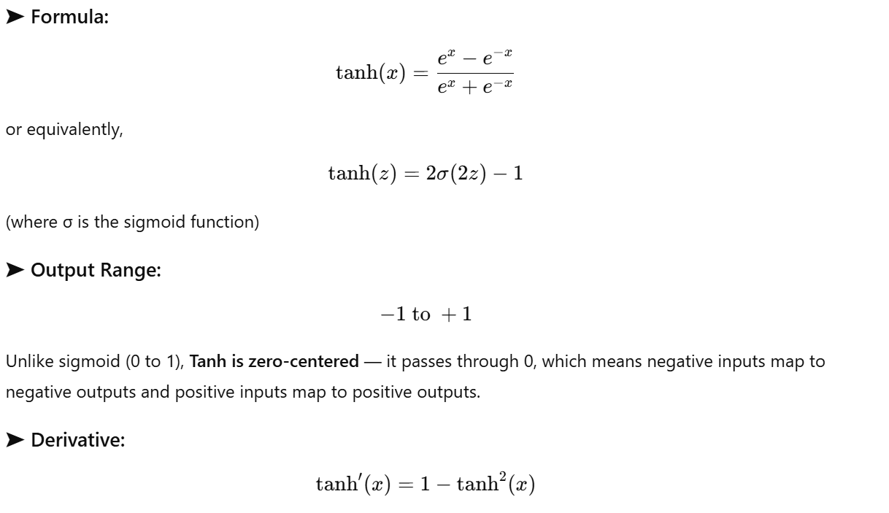

**➤ Advantages:**

1. ✅ **Zero-centered:** Helps gradients flow symmetrically around zero, improving convergence and making optimization smoother.
2. ✅ **Better gradient range:** Derivative up to 1 (vs 0.25 in sigmoid), so **less prone to vanishing gradients**.
3. ✅ Works well in **hidden layers** for medium-sized networks.

**➤ Disadvantages:**

1. ⚠️ **Vanishing gradient still exists** for *deep* networks — because when you multiply many small derivatives (like 0.5, 0.2, 0.05...), they become tiny.
2. ⚠️ **Computationally expensive:** Involves exponential operations (eⁿ and e⁻ⁿ), which take more time compared to simpler functions.

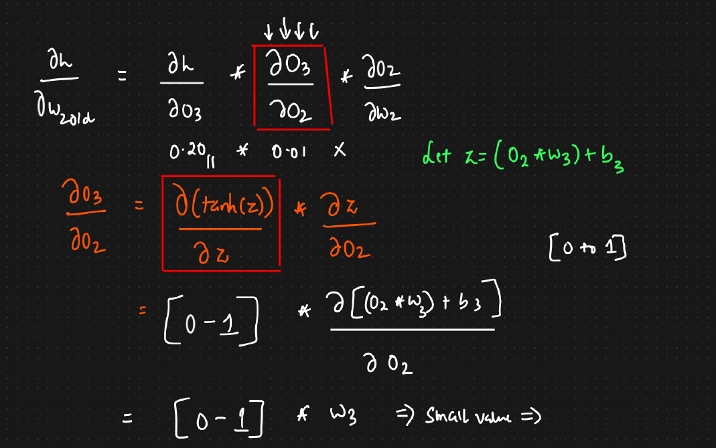

**350. ReLU 🡪 Rectified Linear unit activation function**

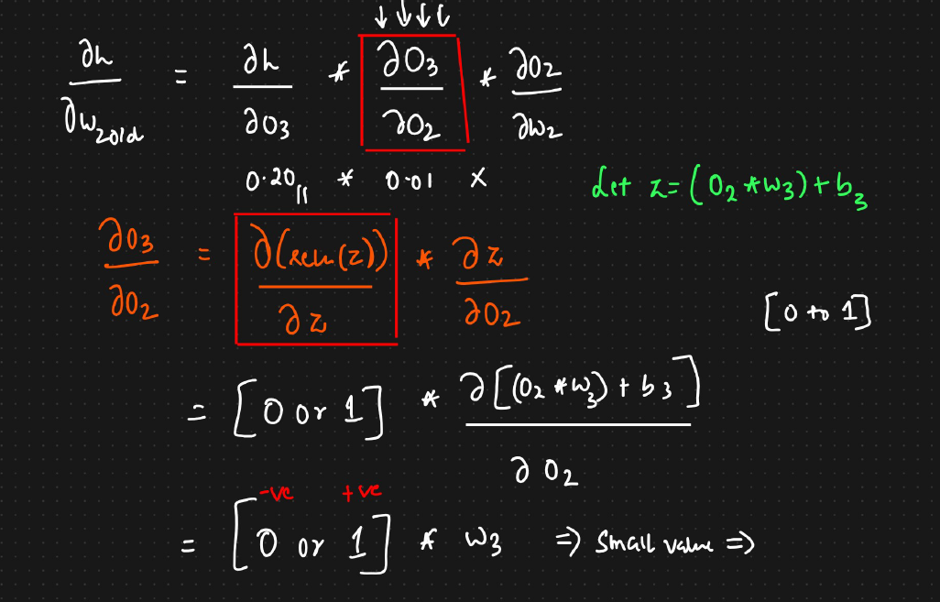

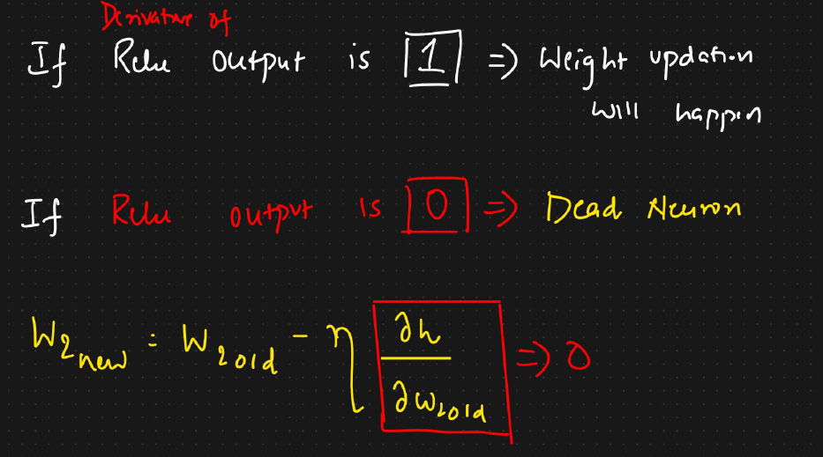

If the input number is **positive , the output is same number**

If the input number is **negative , the output is zero**

In **forward propagation** what ever value we get that is the output of the ReLU for positive number and for negative number it is Zero.

In **Backward propagation** , where we calculate the derivative , the answer is 0 or 1. For positive number it will 1 and for negative value it will be Zero

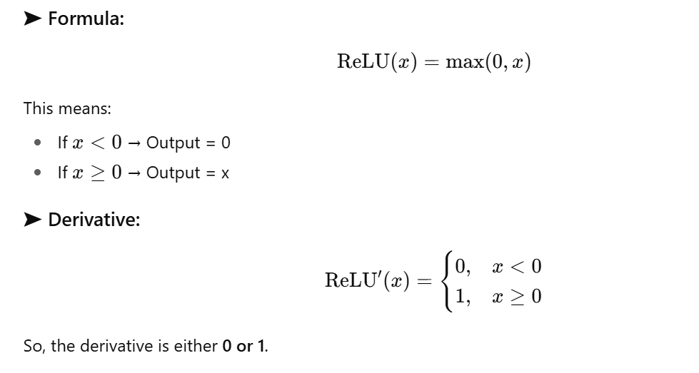

**➤ Advantages:**

1. ✅ **Solves the vanishing gradient problem** — since derivative is 1 for positive inputs, gradients can flow effectively through deep networks.
2. ✅ **Faster computation** — only uses a simple max() operation (no exponentials).
3. ✅ **Efficient learning** — when the derivative is 1, weight updates are strong and effective.
4. ✅ **Linear relationship** in both forward and backward pass makes it simple and computationally efficient.

**➤ Disadvantages:**

1. ⚠️ **Dead Neurons Problem (The "Dying ReLU" Problem):**

This is the biggest issue. During backward propogation If a neuron's input is negative, its output becomes zero. During the learning process (backpropagation), the gradient for that neuron also becomes zero. This means the weights connected to that neuron **stop updating**. The neuron gets "stuck" and no longer participates in learning, effectively becoming a "dead neuron."

* + When x<0x < 0x<0, the derivative becomes 0 → the neuron stops updating its weights (stays inactive permanently).
  + These are called **“Dead Neurons.”**

1. ⚠️ **Not zero-centered:** Outputs are either 0 or positive, so mean activation is not centered around zero — which can slow convergence.

**➤ Summary:**

In short, **ReLU is fast and solves the vanishing gradient problem**, which is why it's so popular. However, it can suffer from **"dead neurons,"** a problem that newer activation functions like **Leaky ReLU** (mentioned at the end) try to fix.

**351. Leaky ReLU 🡪 Rectified Linear unit activation function**

Instead of setting negative inputs to zero (like ReLU), Leaky ReLU multiplies them by a **small constant (α = 0.01)**.

* The line slightly **extends below the x-axis** for negative inputs (not flat like ReLU).
* This ensures gradients **never become zero**, preventing dead neurons

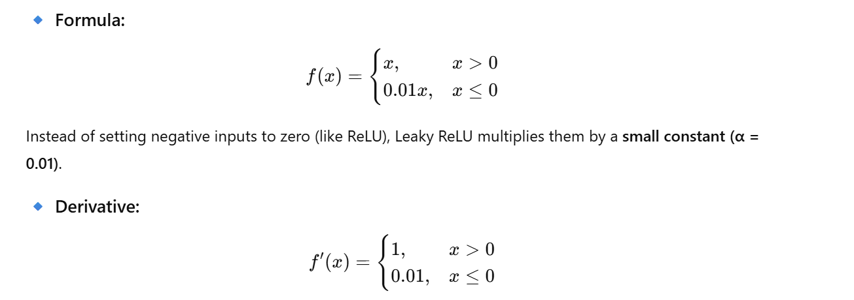

**Advantages:**

* ✅ Solves the **dead neuron problem** (since derivative ≠ 0 for negative x).  
  ✅ Retains all benefits of ReLU — **fast computation** and **non-linearity**.  
  ✅ Works better for deeper networks than plain ReLU.

**Disadvantages:**

* ⚠️ Still **not zero-centered**, meaning the mean activation is not around zero — this can affect optimization slightly.  
  ⚠️ The constant (0.01) is a **hyperparameter**, manually chosen. It may not always be optimal.

**Parametric ReLU (PreLU:**

* This is very similar to Leaky ReLU, but it's more flexible.
* Instead of using a fixed small number like 0.01, it uses a parameter (called alpha) that the neural network learns during training.
* This allows the network to find the best possible "leak" value for itself.

**Advantages:**

* ✅ **No dead neurons**, since derivative never reaches 0.  
  ✅ **Adaptive flexibility:** learns the best negative slope.  
  ✅ **Solves vanishing gradient** and dead neuron issues simultaneously.

**Disadvantages:**

* ⚠️ **More parameters to learn** — can slightly increase training time.  
  ⚠️ Still **not zero-centered**, so weight updates may not be perfectly balanced.

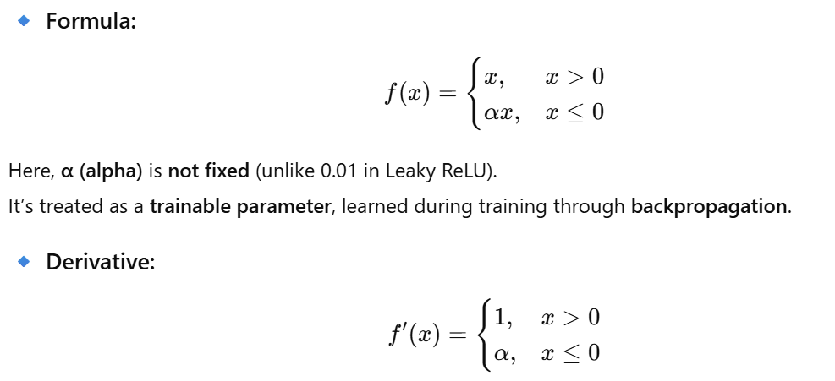

**352. ELU 🡪 Exponential Linear unit activation function**

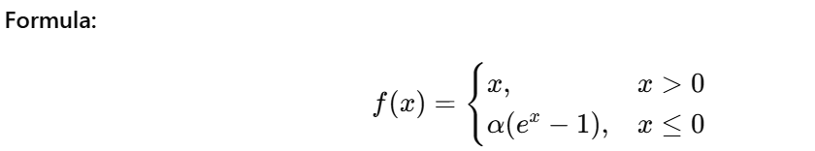

**Output Range: (-α, ∞)**

**Zero-centered? ✅ Yes**

**Use Case: Hidden layers (improved over ReLU & PReLU)**

**Advantages:**✅ No dead neurons  
✅ Zero-centered output (mean near 0 → efficient weight updates)  
✅ Smooth gradient transition

**• Disadvantages:  
⚠️** Slightly computationally expensive (uses exponential)

**Problems with Previous Functions (like ReLU and Leaky ReLU)**

* **ReLU** suffers from the **"Dying ReLU"** problem, where neurons can get "stuck" and stop learning.
* **Leaky ReLU** fixes the "Dying ReLU" problem, but its output is not **"zero-centered."** This means the average output isn't close to zero, which can make the learning process a bit less efficient.

**How ELU is an Improvement**

ELU is a function that tries to get the best of both worlds.

1. **Solves the "Dying ReLU" Problem:**
   * For negative inputs, ELU outputs a small negative number (using an exponential curve).
   * Since the output is never a flat zero for all negative inputs, the learning signal doesn't die, and the neuron can always recover and continue learning.
2. **It is Zero-Centered:**
   * The function produces negative values for negative inputs, which pushes the average output of the neurons closer to zero.
   * This "zero-centered" property helps the network update its weights more efficiently during training.

**Disadvantages of ELU**

* **Slower Calculations:** It uses an exponential function (e^x), which is more computationally intensive (slower) than the simple math used in ReLU and Leaky ReLU.

In short, **ELU is a strong alternative to ReLU** because it solves the "dead neuron" problem and has zero-centered outputs, which often leads to faster and more effective training, despite being slightly slower to compute.

**353. Softmax Activation function**

**What is Softmax used for?**

* It is used in the **output layer** of a neural network.
* Its specific job is to handle **multi-class classification** problems. This is when you need to predict one outcome from several possibilities (e.g., is this picture a cat, a dog, a monkey, or a horse?).
* It converts raw output scores (called **logits**) into **probabilities** that sum to **1**.

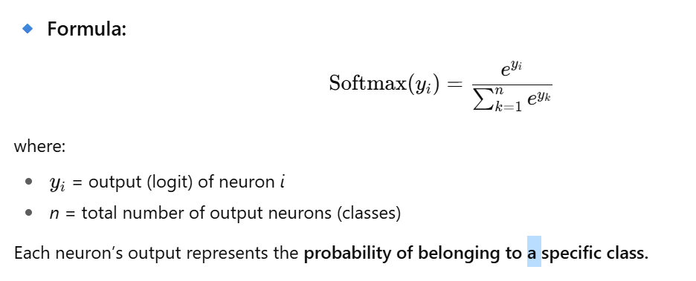

**How is it different from Sigmoid?**

* **Sigmoid** is used for **binary classification** (only two options, like yes/no or 0/1). It gives you a single output number between 0 and 1.
* **Softmax** is used for **multiple classes**. If you have 4 classes, you will have 4 output neurons. Softmax takes the raw scores from all 4 neurons and converts them into probabilities.

**How does Softmax work?**

Imagine your network is trying to classify an image as a cat, dog, monkey, or horse. The final layer before Softmax might output some raw scores (called logits), like:

* Cat: -1
* Dog: 0
* Monkey: 3
* Horse: 5

Softmax turns these scores into probabilities that are easy to understand:

1. **It makes all scores positive** by taking the exponential of each score (e.g., e^-1, e^0, e^3, e^5). This also makes the bigger scores much, much bigger.
2. **It normalizes the scores** by dividing each exponentiated score by the sum of all exponentiated scores.

The result is a list of probabilities that all add up to 1. For the scores above, the output might look something like this:

* Cat: 0.2% probability
* Dog: 0.6% probability
* Monkey: 11.8% probability
* **Horse: 87.4% probability**

Because "Horse" has the highest probability, the network's final prediction would be "Horse".

In short, **Softmax takes the raw output scores of a neural network and turns them into a set of probabilities for each class, making it perfect for multi-class classification.**

**Summary of all activation functions:**

|  |  |  |  |  |  |  |  |  |  |
| --- | --- | --- | --- | --- | --- | --- | --- | --- | --- |
| **Function** | **Formula** | **Output Range** | **Derivative Range** | **Zero-Centered?** | **Fixes Vanishing Gradient?** | **Fixes Dead Neuron?** | **Use Case** | **Key Advantage** | **Key Limitation** |
| **Sigmoid** | 1+e−x1​ | (0,1) | (0,0.25) | ❌ | ❌ | ❌ | Binary classification output | Smooth probabilistic output | Vanishing gradient, slow |
| **Tanh** | ex+e−xex−e−x​ | (-1,1) | (0,1) | ✅ | Partial | ❌ | Hidden layers | Zero-centered output | Vanishing gradient (deep) |
| **ReLU** | max(0,x) | [0,∞) | {0,1} | ❌ | ✅ | ❌ | Hidden layers | Fast & efficient | Dead neurons |
| **Leaky ReLU** | max(0.01x,x) | (-∞,∞) | {0.01,1} | ❌ | ✅ | ✅ | Hidden layers | Solves dead neuron issue | α fixed manually |
| **PReLU** | max(αx,x) | (-∞,∞) | {α,1} | ❌ | ✅ | ✅ | Hidden layers | Learns α adaptively | Extra parameters |
| **ELU** | x if x>0;α(ex−1) if x≤0 | (-α,∞) | Smooth (0–1) | ✅ | ✅ | ✅ | Hidden layers | Zero-centered + smooth | Slightly expensive |
| **Softmax** | eyi​/∑ey | (0,1), sum=1 | varies | ✅ | N/A | N/A | Multi-class output |  |  |

| **Function** | **Formula** | **Output Range** | **Derivative Range** | **Zero-Centered?** | **Fixes Vanishing Gradient?** | **Fixes Dead Neuron?** | **Use Case** | **Key Advantage** | **Key Limitation** |
| --- | --- | --- | --- | --- | --- | --- | --- | --- | --- |
| **Sigmoid** | 11+e−x\frac{1}{1+e^{-x}}1+e−x1​ | (0,1) | (0,0.25) | ❌ | ❌ | ❌ | Binary classification output | Smooth probabilistic output | Vanishing gradient, slow |
| **Tanh** | ex−e−xex+e−x\frac{e^x - e^{-x}}{e^x + e^{-x}}ex+e−xex−e−x​ | (-1,1) | (0,1) | ✅ | Partial | ❌ | Hidden layers | Zero-centered output | Vanishing gradient (deep) |
| **ReLU** | max⁡(0,x)\max(0,x)max(0,x) | [0,∞) | {0,1} | ❌ | ✅ | ❌ | Hidden layers | Fast & efficient | Dead neurons |
| **Leaky ReLU** | max⁡(0.01x,x)\max(0.01x, x)max(0.01x,x) | (-∞,∞) | {0.01,1} | ❌ | ✅ | ✅ | Hidden layers | Solves dead neuron issue | α fixed manually |
| **PReLU** | max⁡(αx,x)\max(\alpha x, x)max(αx,x) | (-∞,∞) | {α,1} | ❌ | ✅ | ✅ | Hidden layers | Learns α adaptively | Extra parameters |
| **ELU** | x if x>0;α(ex−1) if x≤0x \text{ if } x>0; \alpha(e^x-1) \text{ if } x≤0x if x>0;α(ex−1) if x≤0 | (-α,∞) | Smooth (0–1) | ✅ | ✅ | ✅ | Hidden layers | Zero-centered + smooth | Slightly expensive |
| **Softmax** | eyi/∑eyke^{y_i}/\sum e^{y_k}eyi​/∑eyk​ | (0,1), sum=1 | varies | ✅ | N/A | N/A | Multi-class output | Converts logits to probabilities | Sensitive to large values |

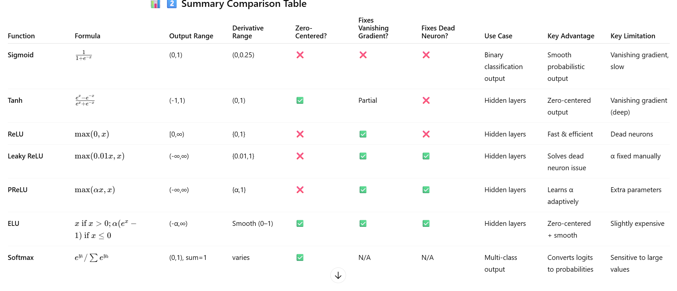

┌────────────────────────────┐

│ 1️⃣ Sigmoid │

│ - Maps 0→1 (Probabilities) │

│ - Problem: Vanishing grad │

└─────────────┬──────────────┘

│

▼

┌────────────────────────────┐

│ 2️⃣ Tanh │

│ - Range: -1→1 │

│ - Zero-centered ✅ │

│ - Still vanishing grad ⚠️ │

└─────────────┬──────────────┘

│

▼

┌────────────────────────────┐

│ 3️⃣ ReLU │

│ - Fast, simple (max(0,x)) │

│ - Fixes vanishing gradient │

│ - Dead neuron issue ⚠️ │

└─────────────┬──────────────┘

│

▼

┌────────────────────────────┐

│ 4️⃣ Leaky ReLU │

│ - Adds small slope (0.01x) │

│ - Fixes dead neuron │

│ - Still not zero-centered │

└─────────────┬──────────────┘

│

▼

┌────────────────────────────┐

│ 5️⃣ PReLU (Parametric) │

│ - Learns slope α adaptively│

│ - Fully flexible ReLU │

└─────────────┬──────────────┘

│

▼

┌────────────────────────────┐

│ 6️⃣ ELU (Exponential) │

│ - Zero-centered ✅ │

│ - No dead neurons ✅ │

│ - Slightly slow ⚠️ │

└─────────────┬──────────────┘

│

▼

┌────────────────────────────┐

│ 7️⃣ Softmax (Output Layer) │

│ - For multi-class tasks 🧩 │

│ - Converts logits→prob. │

└────────────────────────────┘

**354. Which Activation function to apply when**

**1. For Hidden Layers**

* **Rule:** Always use **ReLU** or one of its improved versions (like **Leaky ReLU**, **PReLU**, or **ELU**).
* **Why?** You should **avoid** using older functions like **Sigmoid** or **Tanh** in the hidden layers. In deep networks, they can cause the **"vanishing gradient problem,"** where the network's learning signal becomes so small that it effectively stops learning. ReLU and its variants solve this problem.

**2. For Output Layer**

The choice for the final layer depends on the type of problem you are solving:

* **For Binary Classification:**
  + If you are predicting one of two outcomes (e.g., "yes" or "no", "cat" or "not a cat").
  + **Use the Sigmoid function**
* **For Multi-Class Classification:**
  + If you are predicting one of several possible outcomes (e.g., "cat," "dog," or "horse") **-> Use the Softmax function.**

**Simple Rule of Thumb:**

* **Hidden Layers:** Use **ReLU** (or its variants).
* **Output Layer:** Use **Sigmoid** for two-class problems and **Softmax** for problems with more than two classes.

| **Layer Type** | **Activation Function** | **Use Case** | **Reason / Benefit** |
| --- | --- | --- | --- |
| **Hidden Layers** | **ReLU** | Default for most deep networks | Fast, simple, reduces vanishing gradient |
|  | **Leaky ReLU** | When ReLU neurons “die” | Keeps small gradient for negative inputs |
|  | **Parametric ReLU (PReLU)** | When you want flexibility | Learns slope automatically |
|  | **ELU (Exponential Linear Unit)** | For smoother & zero-centered outputs | Solves dead neuron + zero-centered output |
| **Output Layer (Binary)** | **Sigmoid** | 2-class problems | Converts to probability (0–1) |
| **Output Layer (Multi-class)** | **Softmax** | Multi-class problems | Converts logits → class probabilities |

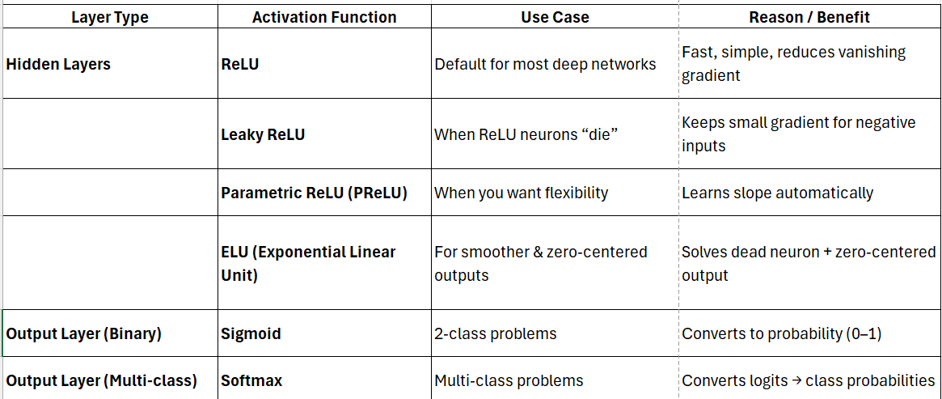

**354. Loss vs Cost functions**

In a **neural network**, after we do all the forward calculations (inputs → weights → activation → output),  
we compare our **predicted output (ŷ)** with the **actual output (y)**.

This difference is what we try to **minimize** — that’s where **loss** and **cost functions** come in.

**🔹 Loss Function**

* It measures the **error for one data point**.
* It shows how far the prediction (ŷ) is from the true value (y).
* Example:

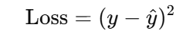

* During training, the model calculates this for **each single data point**, updates the weights (using **backpropagation**), and moves closer to the correct output.

**🔹 Cost Function**

* It measures the **average error for all data points** in the training set (or a batch).
* Example:

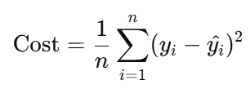

* So, it’s just the **mean of all losses**.
* After computing this average, the model updates all weights **once** per iteration.

**355. Regression Cost functions**

**A. Mean Squared Error (MSE)**

**Formula:**

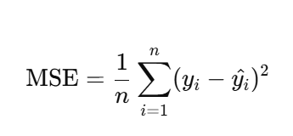

**Meaning:**

* It takes the **square of the difference** between actual and predicted values.
* Squaring ensures the error is always positive and penalizes large errors more heavily.

**Visualization:**

* If you plot weights (W) vs. loss, it forms a **parabolic (U-shaped) curve**.
* The bottom point is called the **Global Minimum** — the place where error is lowest.

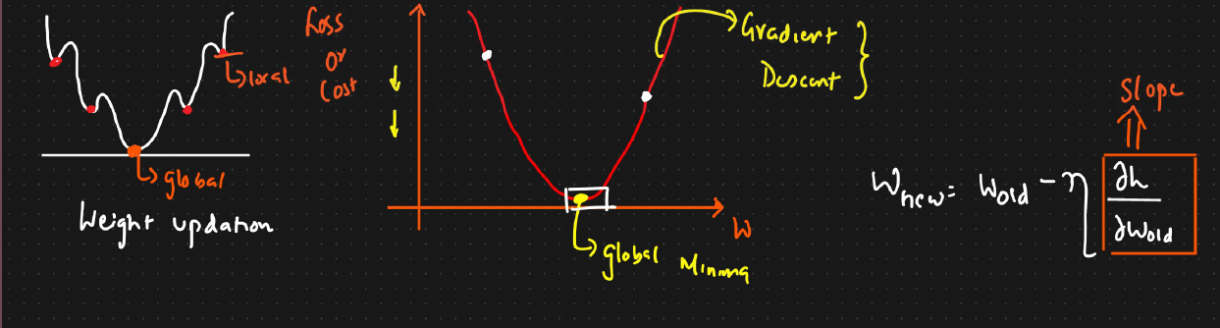

**Advantages:**  
✅ Differentiable — helps calculate gradients for backpropagation.  
✅ Has a **clear global minimum**, ensuring stable convergence. It is one global and local minima  
✅ Works well when data **does not have outliers**.

**Disadvantages:**  
⚠️ **Not robust to outliers** — squaring amplifies big errors, so one bad data point can distort learning.

⚠️ Penalizing the error  
⚠️ Sensitive to extreme values.

**B. Mean Absolute Error (MAE)**

**Formula:**

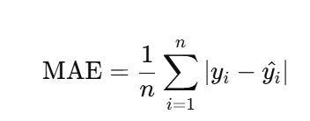

**Meaning:**

* It takes the **absolute difference** between actual and predicted values.
* Does not square the error — treats all errors equally.

**Advantages:**  
✅ **Robust to outliers** — big errors don’t dominate learning.  
✅ Simple and intuitive.

**Disadvantages:**  
⚠️ The graph is **not smooth (not parabolic)** — has a sharp “V” shape.  
⚠️ **Slower convergence** — gradients aren’t well-defined at the tip of the “V”.  
⚠️ Uses **subgradients** instead of smooth derivatives.

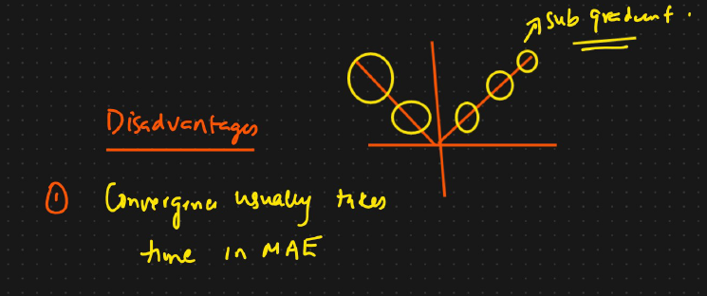

**C. Huber Loss**

**Formula:**

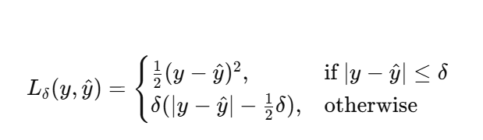

**Meaning:**

* **Combination of MSE and MAE.**
* When the error is **small (within threshold δ)** → use **MSE** (sensitive, good for accuracy).
* When error is **large (beyond δ)** → use **MAE** (robust to outliers).

**Advantages:**  
✅ Combines best of both worlds — smooth like MSE, robust like MAE.  
✅ Handles outliers better.  
✅ Differentiable everywhere.

**Disadvantages:**  
⚠️ Slightly more **complex to compute**.  
⚠️ Requires tuning of hyperparameter δ.

**D. Root Mean Squared Error (RMSE)**

**Formula:**

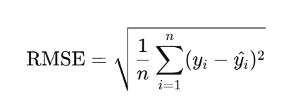

**Meaning:**

* Just the **square root of MSE**.
* Keeps units same as output variable (e.g., if target is in meters, RMSE is also in meters).

**Advantages:**  
✅ Interpretable and commonly reported metric.  
✅ Penalizes large errors more due to squaring.

**Disadvantages:**  
⚠️ Same as MSE — **not robust to outliers**.  
⚠️ Slightly more computational due to square root.

**⚙️ Why MSE Forms a Parabola Curve**

* When you plot **weights (W)** on the X-axis and **loss (MSE)** on the Y-axis:  
  You get a **U-shaped curve (parabola)**.
* The minimum point is called **global minima**, where loss is smallest.
* During training, the optimizer (like Gradient Descent) moves step by step toward this minimum.

This makes MSE a **preferred loss function** for smooth and stable learning when data is clean.

**356. Classification Cost functions**

For classification tasks, we use a special type of loss called Cross-Entropy Loss (or Log Loss).  
It helps the model learn probabilities for different classes.

1. **Binary Classification** → Two possible outcomes (e.g., Cat or Dog)
2. **Multi-Class Classification** → More than two outcomes (e.g., Cat, Dog, Bird)

For these, we use **different versions of Cross-Entropy Loss**.

**A. Binary Cross-Entropy (for Binary Classification)**

**Used When:** Output has **two classes** (0 or 1).  
**Example:** Predicting whether an email is spam (1) or not spam (0).

**Formula:**

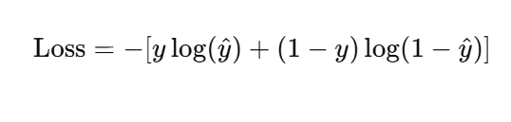

Where:

* **y** = actual value (0 or 1)
* **ŷ (y-hat)** = predicted probability (between 0 and 1)  
  (usually obtained using a **Sigmoid activation function** in the output layer)

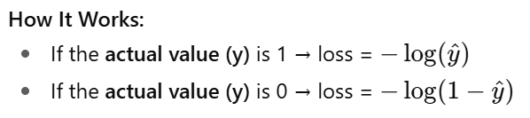

This ensures:

* High penalty for wrong predictions.
* Low loss when predictions are correct.

**Example Workflow:**

1. Inputs (x₁, x₂, x₃) go through the network.
2. After the last layer, **Sigmoid activation** is applied.
3. The output **ŷ** gives a probability (e.g., 0.8 → 80% chance of being 1).
4. Binary cross-entropy computes how close this is to the actual label (0 or 1).
5. The **optimizer** updates the weights to reduce this loss.

✅ **Key Points:**

* Works perfectly with **Sigmoid activation** in the output layer.
* Suitable for **binary classification problems**.

**B. Categorical Cross-Entropy (for Multi-Class Classification)**

**Used When:** You have **3 or more classes** (e.g., sentiment analysis → Positive, Negative, Neutral).  
Each data point belongs to **one** of several classes.

**Step 1: One-Hot Encoding**

Before using categorical cross-entropy, we convert class labels to **one-hot encoded format**.

Example:

| **Class** | **One-Hot Vector** |
| --- | --- |
| Good | [1, 0, 0] |
| Bad | [0, 1, 0] |
| Neutral | [0, 0, 1] |

**Formula:**

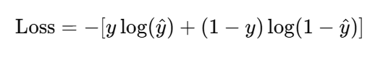

Where:

* **C** = number of categories
* **y₍ᵢⱼ₎** = actual (1 if sample i belongs to class j, otherwise 0)
* **ŷ₍ᵢⱼ₎** = predicted probability for class j (output of **Softmax activation**)

**How It Works:**

1. Apply **Softmax activation** in the output layer.
   * It converts raw outputs (logits) into **probabilities** that sum to 1.
   * Example:  
     For 3 classes → [0.2, 0.3, 0.5]  
     → Means: 20% chance of Class 1, 30% of Class 2, 50% of Class 3.
2. The **true label** (e.g., [0, 0, 1]) is multiplied by log of predicted probability.
3. The model gets **penalized** if it predicts a low probability for the correct class.

✅ **Key Points:**

* Works with **Softmax activation** in the output layer.
* Suitable for **multi-class classification**.
* Provides **probabilities for all classes**.

**C. Sparse Categorical Cross-Entropy**

**Used When:** You have multi-class classification, but instead of one-hot vectors, your labels are in **integer form**.

Example:

| **Class** | **Label** |
| --- | --- |
| Good | 0 |
| Bad | 1 |
| Neutral | 2 |

**Formula:**

It uses the same mathematical definition as categorical cross-entropy internally,  
but it expects integer labels instead of one-hot encoding.

| **Loss Function** | **Used For** | **Activation Function (Output Layer)** | **Input Labels** | **Output** | **Advantages** | **Disadvantages** |
| --- | --- | --- | --- | --- | --- | --- |
| **Binary Cross-Entropy** | Binary Classification (2 classes) | Sigmoid | 0 or 1 | Probability between 0 and 1 | Simple, effective | Only for binary tasks |
| **Categorical Cross-Entropy** | Multi-Class Classification | Softmax | One-hot encoded | Probabilities for all classes | Provides probability of all classes | Needs one-hot encoding |
| **Sparse Categorical Cross-Entropy** | Multi-Class Classification | Softmax | Integer labels (0,1,2,…) | Index of most likely class | Saves memory, simpler | Loses probability info |

**358. Which Cost functions to use when**

**1. For Binary Classification Problems**

*(Predicting one of two outcomes, like "yes" or "no")*

* **Hidden Layers:** Use **ReLU** or one of its variants (like Leaky ReLU).
* **Output Layer:** Use the **Sigmoid** activation function.
* **Loss Function:** Use **Binary Cross-Entropy**.

**2. For Multi-Class Classification Problems**

*(Predicting one of several outcomes, like "cat," "dog," or "horse")*

* **Hidden Layers:** Use **ReLU** or one of its variants.
* **Output Layer:** Use the **Softmax** activation function.
* **Loss Function:** Use **Categorical Cross-Entropy** or **Sparse Categorical Cross-Entropy**.

**3. For Regression Problems**

*(Predicting a continuous number, like a price or temperature)*

* **Hidden Layers:** Use **ReLU** or one of its variants.
* **Output Layer:** Use a **Linear** activation function (which basically means no activation is applied).
* **Loss Function:** Use a regression loss like **MSE** (Mean Squared Error), **MAE** (Mean Absolute Error), or Huber Loss.

| **Problem Type** | **Hidden Layer Activation** | **Output Layer Activation** | **Loss Function** | **Remarks / Example** |
| --- | --- | --- | --- | --- |
| **Binary Classification** | ReLU / Leaky ReLU / PReLU / ELU | Sigmoid | Binary Cross-Entropy | Predict yes/no, spam/not spam, etc. |
| **Multi-Class Classification** | ReLU / Variants | Softmax | Categorical Cross-Entropy / Sparse Categorical Cross-Entropy | Predict multiple categories like Dog, Cat, Bird |
| **Regression** | ReLU / Variants | Linear | MSE / MAE / Huber / RMSE | Predict continuous output (e.g., price, temperature) |

**359. Gradient Decent Optimizer**

**What Are Optimizers?**

* In deep learning, after we calculate the **loss**, we must adjust the **weights** so that the loss becomes smaller.
* The mathematical process of adjusting weights to minimize loss is handled by an **optimizer**.

✅ **Goal of optimizer:**  
Find the best weights (at the **global minimum** of the loss function curve) as efficiently as possible.

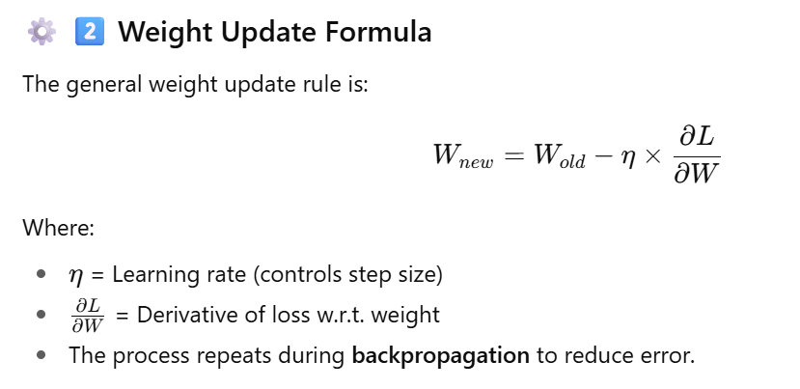

**A. Gradient Descent (GD)**

**Concept:**  
Takes *all data points* at once to compute the gradient (error) and update weights.

* Each epoch = 1 forward pass + 1 backward pass using all data and we will be performing multiple epocs until we reach global minima
* The curve of the cost function looks like a smooth **U-shape (parabola)**.
* The goal is to reach the **global minima** (lowest point).

**Advantages:**  
✅ Stable and smooth convergence.

**Disadvantages:**  
⚠️ Needs **huge memory** (RAM/GPU) for large datasets (e.g., millions of data points).  
⚠️ Slow and **resource intensive**.

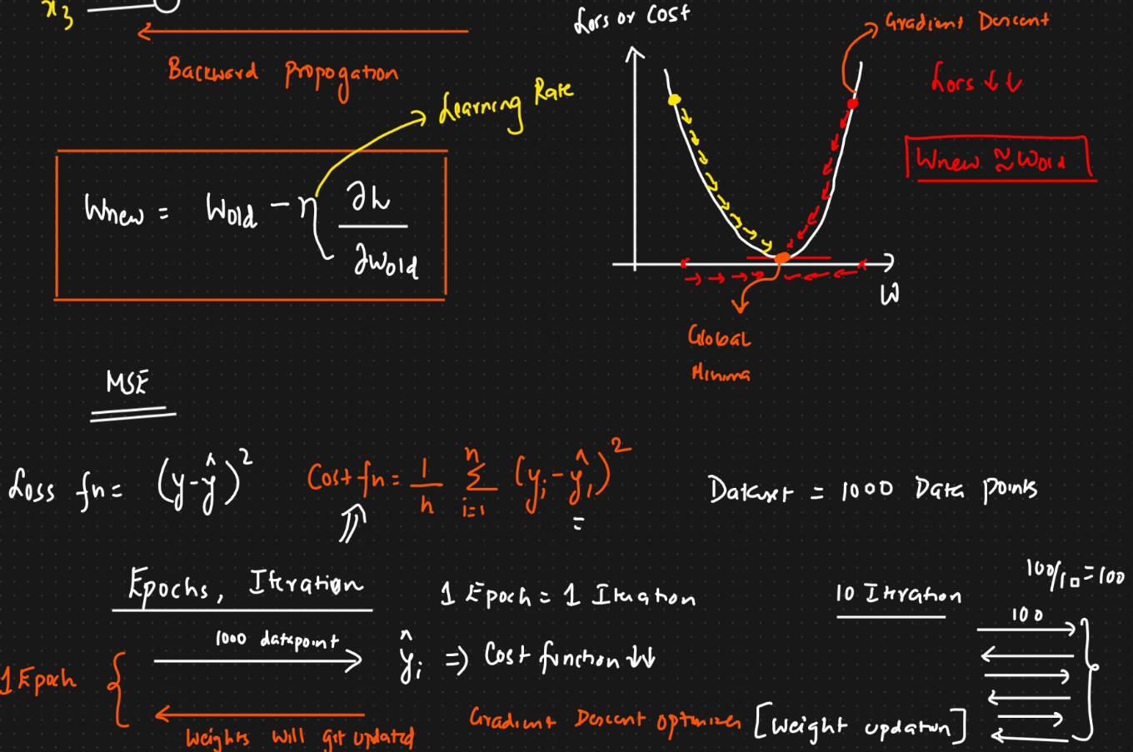

**360. Stochastic Gradient Descent (SGD)**

**How it works:** To solve the memory problem of GD, SGD updates the weights after processing just **one single data point** at a time. If you have 1,000 data points, it will perform 1,000 small updates to complete one epoch.

**Concept:**  
Instead of using all data at once, SGD updates weights using **one sample at a time**.

* Each data point updates weights immediately.
* Reduces memory usage — can work on smaller machines (4–8 GB RAM).

**Advantages:**  
✅ Solves resource problem (no need for large memory).  
✅ Updates happen faster per sample.

**One epoc can have multiple iterations and in SGD we will have 1000 iterations**

**Disadvantages:**  
⚠️ **Noisy convergence** — the loss fluctuates a lot.  
⚠️ **Takes longer** to converge because of randomness.  
⚠️ Gradient path zig-zags before reaching the minimum.

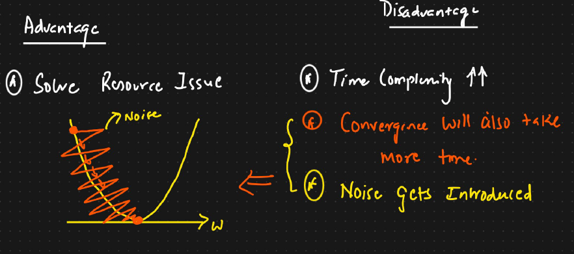

**361. Mini BatchStochastic Gradient Descent**

**Concept:**  
Combines the best of GD and SGD.

* Instead of one sample (SGD) or full dataset (GD), it uses **batches of data (e.g., 32, 64, 128 samples)** at a time.
* Each batch is used for one iteration → smoother and faster convergence.

**Advantages:**  
✅ Reduces noise (smoother loss curve).  
✅ Faster training than full GD.  
✅ Works well with GPU parallel processing.

**Disadvantages:**  
⚠️ Requires tuning the **batch size** (too small = noisy, too large = slow).

**362. Stochastic Gradient Descent with momentum**

**Problem Solved:**  
Mini-Batch SGD still has **some noise** and **slow convergence**.

**Idea:**  
Add **momentum** — helps accelerate gradient descent by remembering the previous update direction. During back propagation , we should update weights along with bias

**Analogy:**  
Think of a ball rolling downhill — momentum helps it move faster and not get stuck in small bumps.

**How It Works:**  
Adds an **exponential weighted average** of past gradients to smooth the path.

**Formula:**

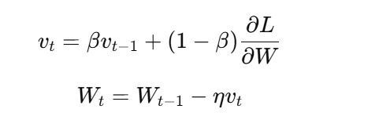

**Advantages:**  
✅ Reduces oscillations (smoother curve).  
✅ Converges faster to the global minimum.

**Key Concept:**  
Uses a **beta (β)** term (usually 0.9–0.99) to control smoothing strength.

=============== In Detail ===================

**Intuition:**  
Instead of only considering the current gradient, we also remember the **previous direction** and continue moving that way — just like adding momentum to a rolling ball.

It means:

Don’t stop or change direction immediately — keep going with a “push” from previous updates.

This idea is implemented using an **Exponential Weighted Average (EWA)**.

**🧮 4️⃣ Basic Weight Update Rule (Without Momentum)**

In standard gradient descent:

Where:

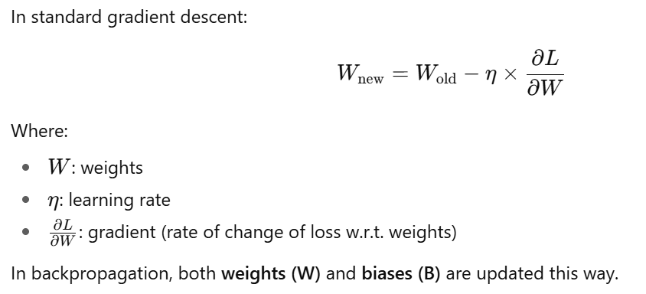I

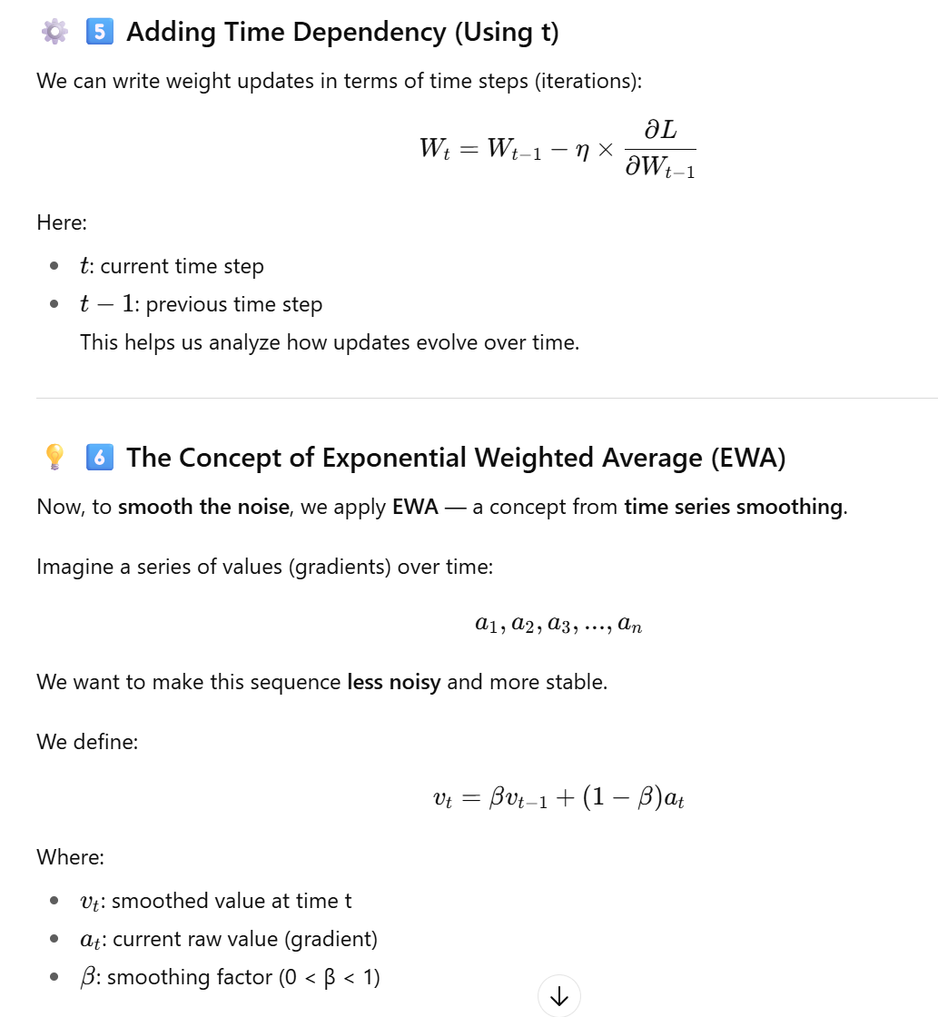

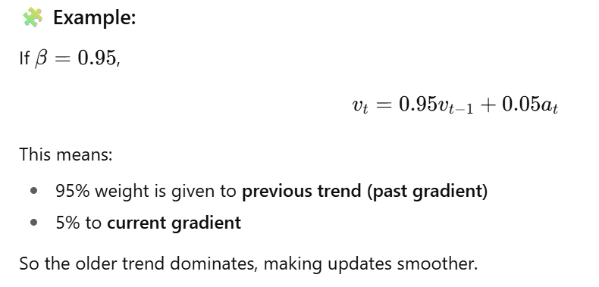

**363. Adagrad :**

**Adagrad** stands for **Adaptive Gradient Descent**.  
It was developed to improve the traditional **Gradient Descent** algorithm by making the **learning rate dynamic** (changing during training) instead of fixed.

Earlier, in all optimizers (like **SGD**, **Mini-Batch SGD**, or **Momentum**):

* The **learning rate (η)** was **fixed** (e.g., 0.001 or 0.01).
* This meant the model took **steps of the same size** throughout training, regardless of how close it was to the minimum.

But — in real scenarios:

* In the **beginning**, the optimizer should take **large steps** (to move faster toward the minimum).
* When it reaches **near the minimum**, it should take **smaller steps** (to avoid overshooting and stabilize).

That’s where **Adagrad** comes in. It automatically adjusts the **learning rate** as training progresses.

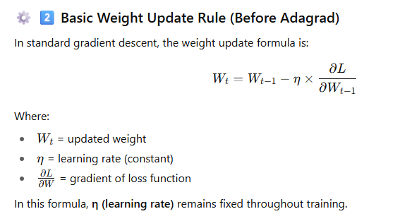

**The Need for Dynamic Learning Rate**

We want the **learning rate to be adaptive**, meaning:

* **High at the beginning** → to move quickly toward the minimum.
* **Low near the end** → to make fine adjustments smoothly.

In other words:

“Start with large steps, finish with small steps.”

Adagrad implements this idea automatically.

**Adagrad Optimizer: Making Learning Rate Dynamic**

In Adagrad, the learning rate changes as training progresses.  
It introduces a **new term (αₜ)** into the denominator of the learning rate to make it adaptive.

The modified weight update rule becomes:

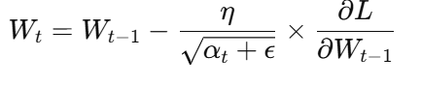

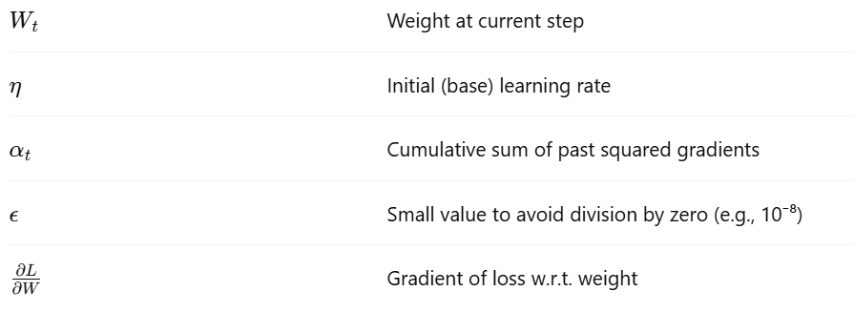

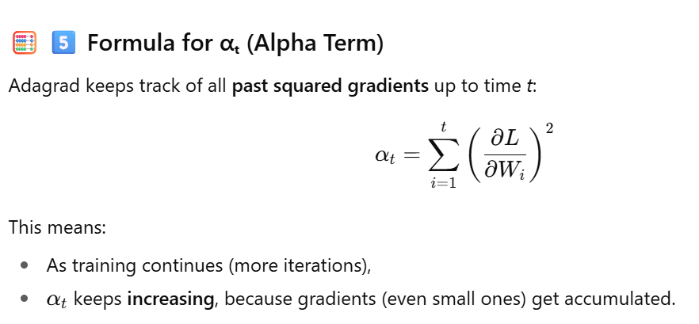

**How Adagrad Works Step by Step**

1. **Start:**  
   Initialize weights and base learning rate (η = 0.01).
2. **During training:**  
   Compute the gradient (∂L∂W\frac{\partial L}{\partial W}∂W∂L​) for each step.
3. **Update αₜ:**  
   Add the squared gradient to the cumulative total.

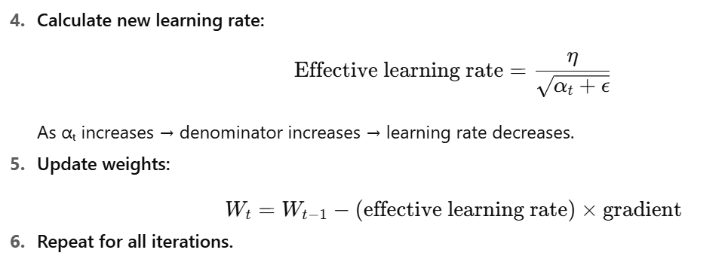

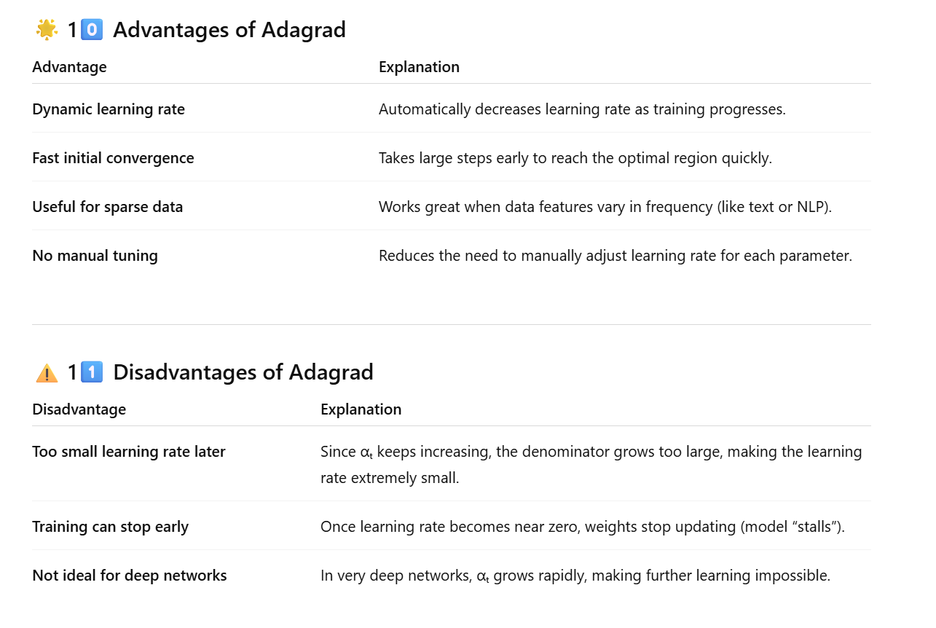

**364. RMSPROP and Adadelta :**

Adagrad had a **big problem** 👇

Over time, it kept **reducing the learning rate too much**, making it **almost zero** — and stopping the model from learning further.

This happened because Adagrad’s denominator term (αt\alpha_tαt​) kept increasing endlessly as it summed up all the squared gradients from start to end.

So, to **fix this issue**, two new optimizers were introduced:

* **Adadelta**
* **RMSProp**

Both of them were designed to **control** or **smooth** how the learning rate changes over time — without letting it shrink to zero.

**How Adadelta and RMSProp Fix This**

Both **Adadelta** and **RMSProp** solve Adagrad’s issue by introducing **Exponential Weighted Average (EWA)** instead of cumulative summation.

This means:

Instead of summing *all* past gradients (like Adagrad), we take a **smoothed average** of recent gradients only.

This keeps learning **adaptive but stable** — it doesn’t slow down too much.

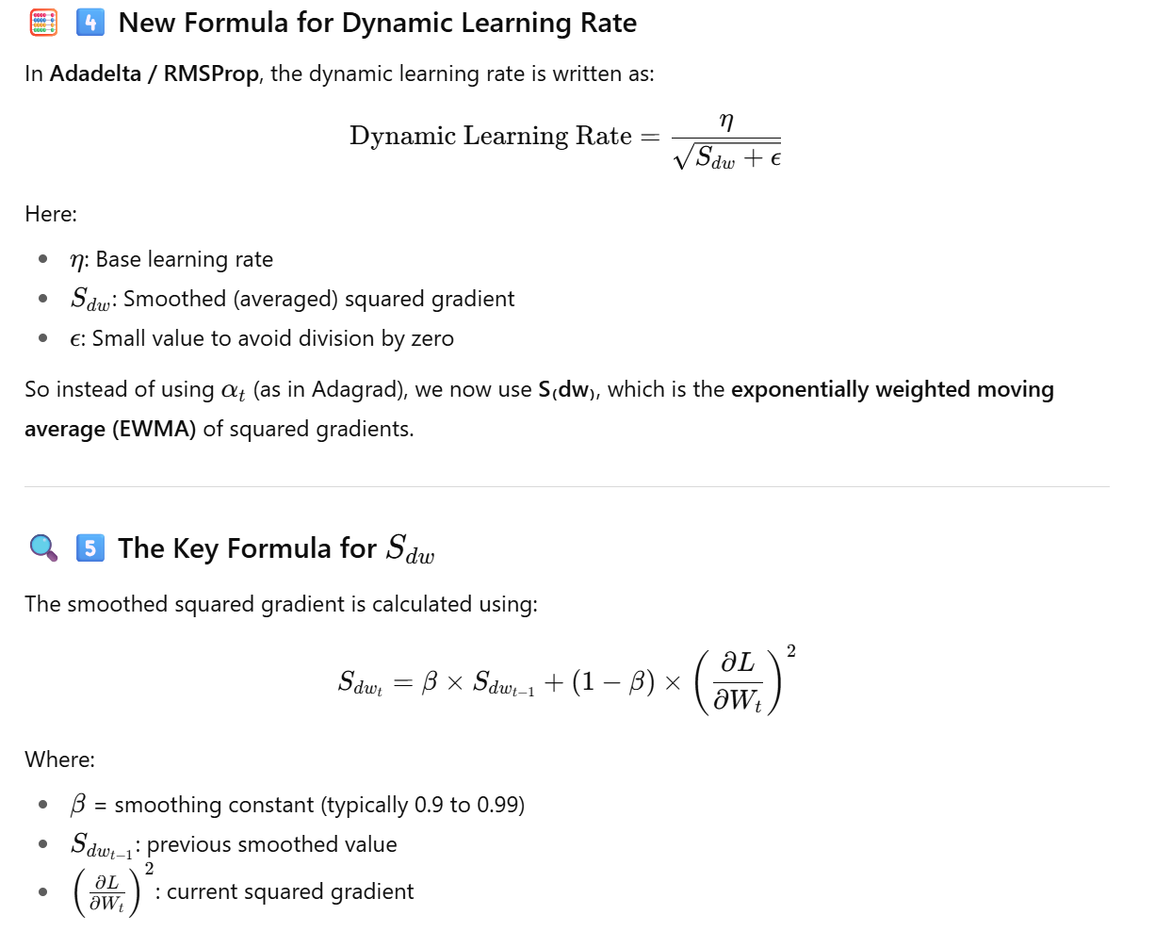

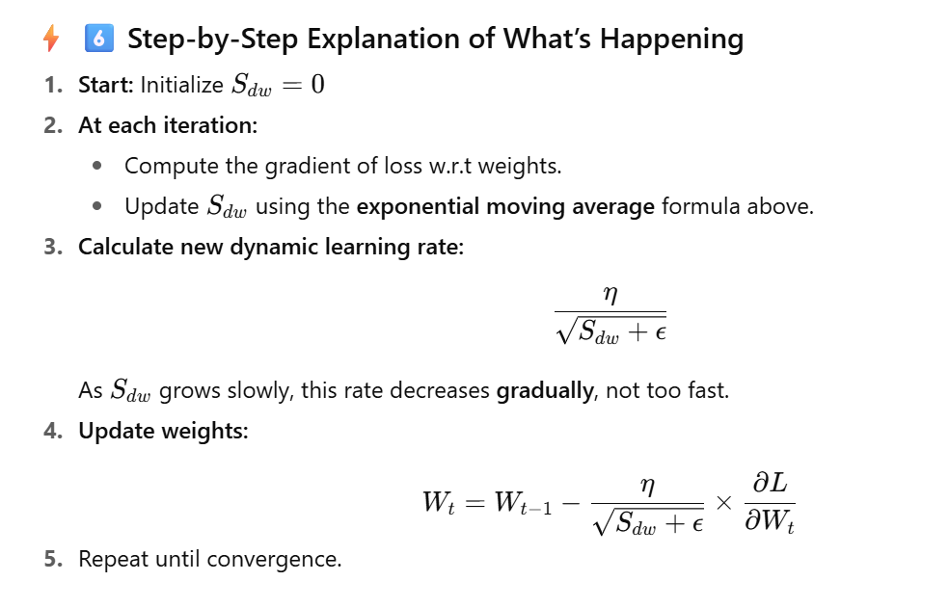

**Difference Between Adadelta and RMSProp**

Both use the same core concept of **exponential moving average**, but:

* **RMSProp** was proposed by **Geoffrey Hinton** in his lecture.
* **Adadelta** was proposed by **Matthew Zeiler** as a **modified version of Adagrad**.

In practical terms:

✅ Both behave almost the same in most frameworks (like TensorFlow or PyTorch).

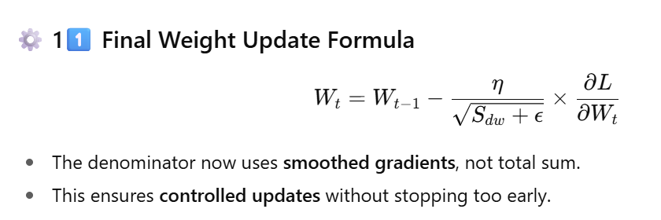

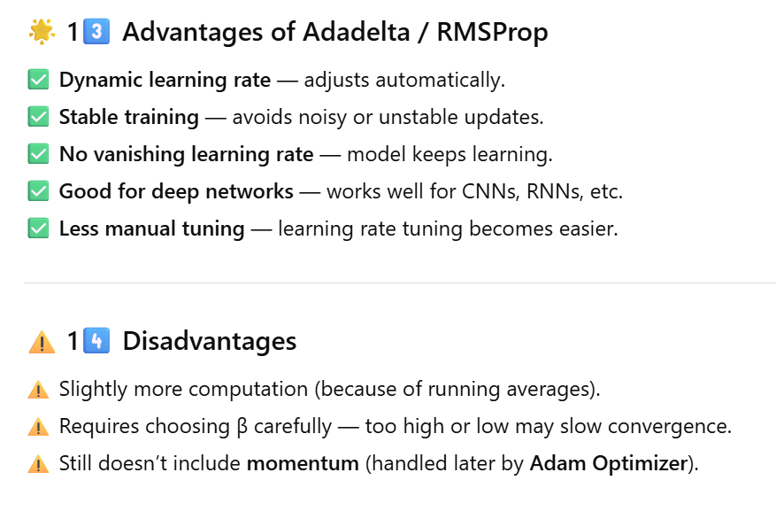

**365 Adam Optimizer:**

**Adam** stands for **Adaptive Moment Estimation**.

It is the **most popular and powerful optimizer** in deep learning today because it **combines the best features** of the previous optimizers we learned:

| **Optimizer** | **What It Contributed** |
| --- | --- |
| **SGD with Momentum** | Adds *momentum* to reduce oscillations and smooth the path to minimum |
| **RMSProp** | Adds *adaptive learning rate* and *exponential smoothing* of gradients |

👉 **Adam = Momentum + RMSProp**

So, Adam takes both these advantages:

* **Momentum:** Smooths the updates by considering past gradients (helps move consistently in the right direction)
* **RMSProp:** Adapts learning rate automatically for each parameter

**⚙️ 2️⃣ Why Was Adam Developed?**

Earlier optimizers had some limitations:

* **SGD** was noisy and slow.
* **Momentum** helped but still needed a fixed learning rate.
* **Adagrad** and **RMSProp** adapted learning rate but could still lose stability.

💡 Adam solved all these by:

1. Using **momentum** (for smooth updates).
2. Using **adaptive learning rate** (like RMSProp).
3. Combining them in a single weight update formula.

**Core Concept of Adam**

Adam uses **two moving averages**:

1. **First Moment (vₜ):** Average of past gradients (momentum part)
2. **Second Moment (sₜ):** Average of past squared gradients (RMSProp part)

These are both calculated using **Exponential Weighted Average (EWA)**.

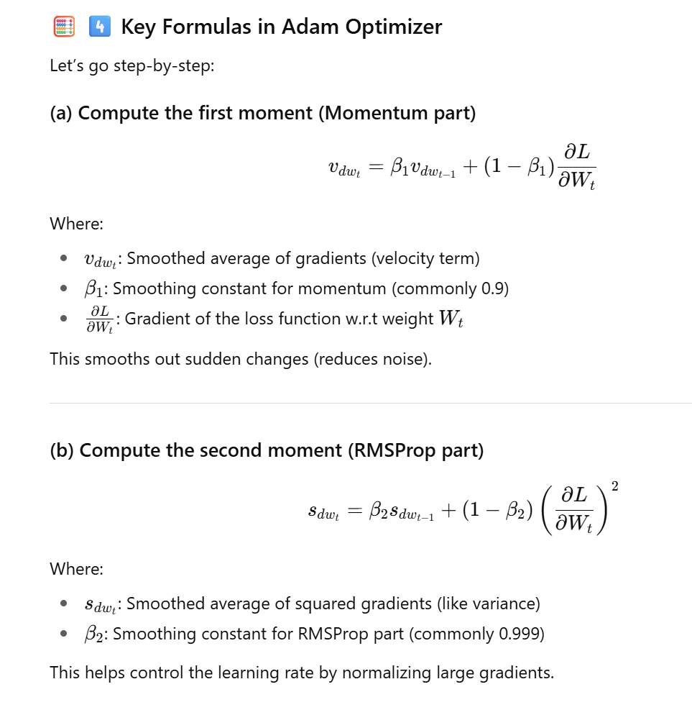

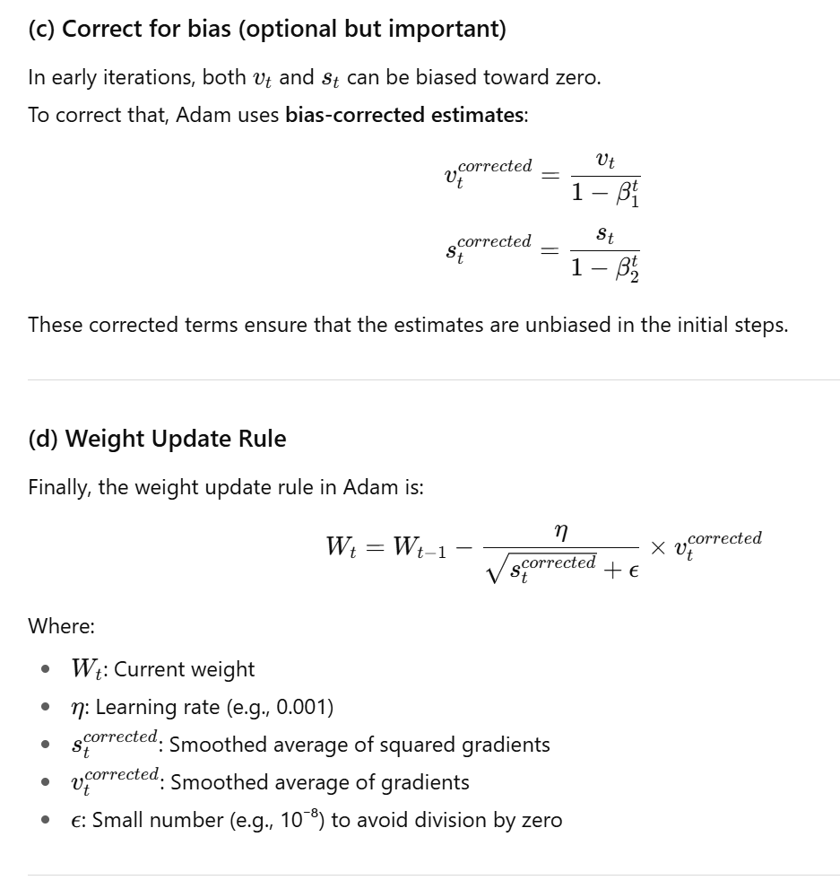

**Intuitive Understanding**

Think of a ball rolling downhill on a rough surface:

* **Momentum (vₜ):** Gives it a push so it doesn’t stop at every bump.
* **RMSProp (sₜ):** Controls how fast it should roll (adaptive step size).
* **Adam:** Combines both — the ball rolls smoothly and steadily towards the lowest point (global minimum).

**6️. How Learning Happens in Adam**

**Step-by-step:**

1. Compute the gradient of the loss.
2. Update the **momentum** term (vₜ) → smoothens gradient.
3. Update the **RMS term** (sₜ) → controls learning rate.
4. Use both terms to calculate new weight WtW_tWt​.
5. Repeat for each iteration until convergence.

Here’s a **concise and clear explanation** of the difference between **Iteration**, **Batch**, and **Epoch** in deep learning 👇

| **Term** | **Definition** | **Example (Assume 1,000 samples & batch size = 100)** |
| --- | --- | --- |
| **Batch** | A **subset** of the training data processed together before updating weights. | 1 batch = 100 samples |
| **Iteration** | **One update step** of the model’s weights after processing **one batch**. | 10 iterations = 1,000 samples / 100 batch size |
| **Epoch** | **One full pass** through the entire training dataset (all batches once). | 1 epoch = 10 iterations (all 1,000 samples processed once) |

**💡 Simple Summary:**

* **Batch →** The data you feed at once.
* **Iteration →** One update of weights (after one batch).
* **Epoch →** When the model has seen **all training data once**.

| **Optimizer** | **Key Idea** | **Memory Need** | **Noise Level** | **Learning Rate Type** | **Speed of Convergence** | **Remarks** |
| --- | --- | --- | --- | --- | --- | --- |
| **Gradient Descent** | Uses all data at once | High | Smooth | Fixed | Moderate | Stable but resource-heavy |
| **Stochastic GD** | 1 sample at a time | Low | High | Fixed | Slow | Resource-light, noisy |
| **Mini-Batch SGD** | Batch updates | Medium | Medium | Fixed | Faster | Best trade-off |
| **SGD with Momentum** | Adds momentum | Medium | Low | Fixed | Fast | Smoother convergence |
| **Adagrad** | Adaptive rate | Medium | Medium | Dynamic | Initially fast | May stop too early |
| **Adadelta / RMSProp** | Adaptive + smoothing | Medium | Low | Dynamic | Fast | Solves Adagrad’s issues |
| **Adam** | Combines Momentum + RMSProp | Medium | Very Low | Dynamic | Very Fast | Most commonly used |

**366 Exploding Gradient Decent:**

Here’s a **very detailed and easy-to-understand summary** of your attached file — it explains **Weight Initialization Techniques** in deep learning, including

* **Uniform Distribution**,
* **Xavier (Glorot) Initialization**,
* **He (Kaiming) Initialization**

1. **What Is Weight Initialization?**

When training a neural network, we start with **random weights**.  
But if these weights are not chosen properly:

* Training becomes **unstable**
* Gradients may **explode** or **vanish**
* The network **fails to learn**

So, **weight initialization** is the method used to **set the initial weights** of neurons before training begins — in a way that helps the network learn **fast and stably**.

**2.Three Golden Rules for Weight Initialization**

When initializing weights, we must ensure that:

| **Rule** | **Explanation** |
| --- | --- |
| 1️. **Weights should be small** | If weights are large, it can cause **exploding gradients** (weights grow uncontrollably). |
| 2️. **Weights should not be the same** | If all weights are identical, all neurons learn the **same features**, which kills learning diversity. |
| 3️. **Weights should have good variance** | Variance ensures each neuron learns **different aspects** of data. It prevents dead neurons or uniform outputs. |

So — **weights should be small, random, and diverse.**

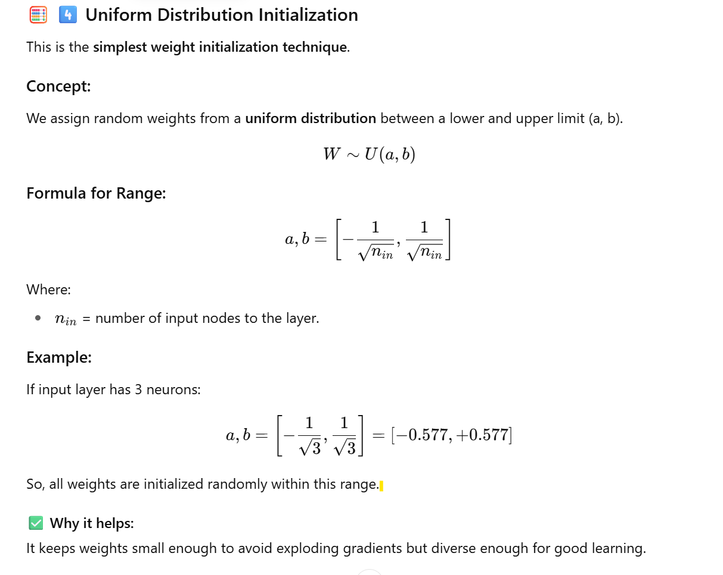

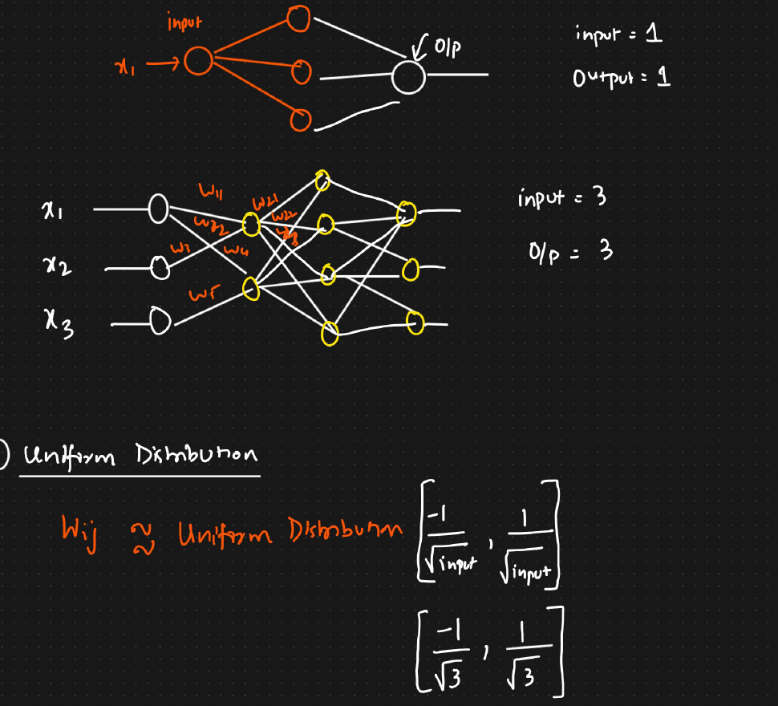

**Xavier (Glorot) Initialization**

**Types of Xavier Initialization:**

There are two types:

**(a) Xavier Normal Initialization**

Weights are taken from a **normal (Gaussian)** distribution.

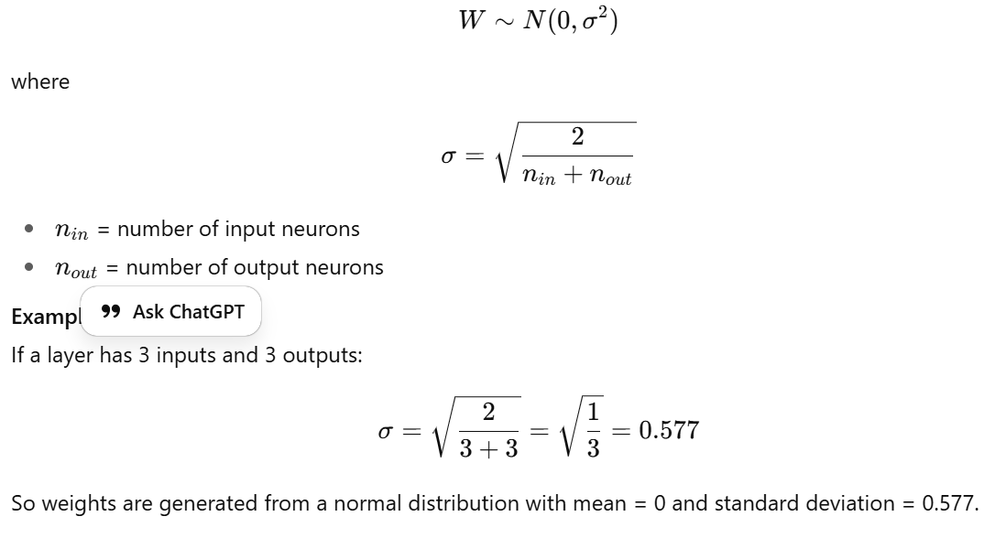

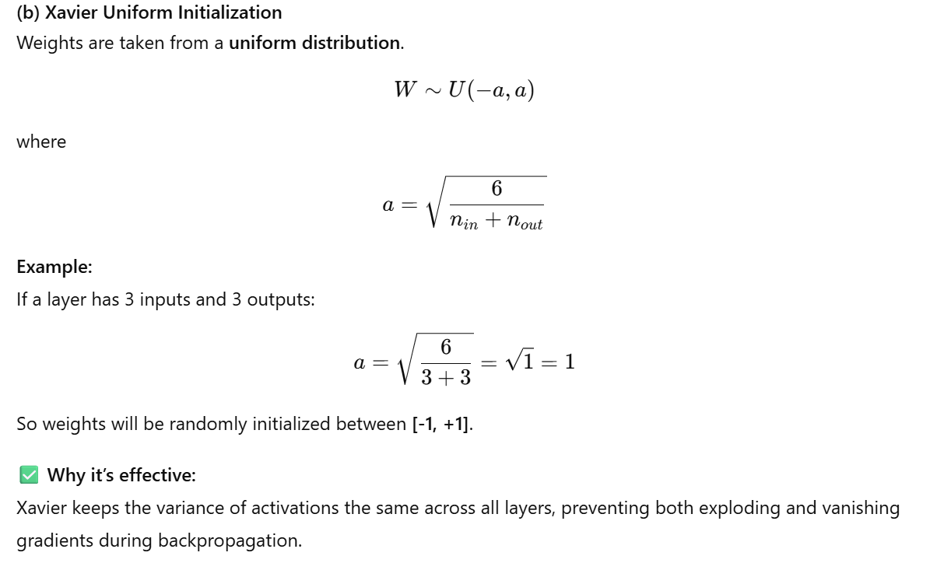

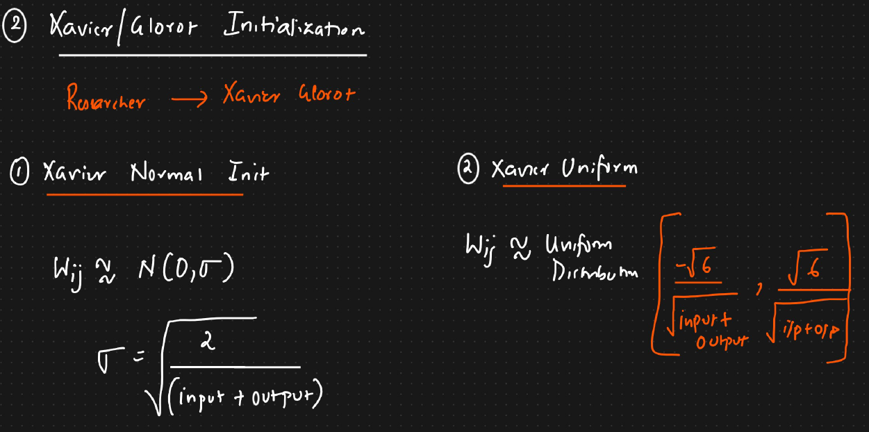

**He (Kaiming) Initialization**

This method was proposed by **Kaiming He**, mainly for **ReLU** and its variants (**Leaky ReLU, PReLU, ELU**).

**🧩 Purpose:**

ReLU activation sets all negative values to 0, so **half of the neurons are inactive at a time**.  
Hence, we need slightly higher variance to compensate for the dead neurons.

**Types of He Initialization:**

**(a) He Normal Initialization**

Weights are taken from a **normal distribution**:

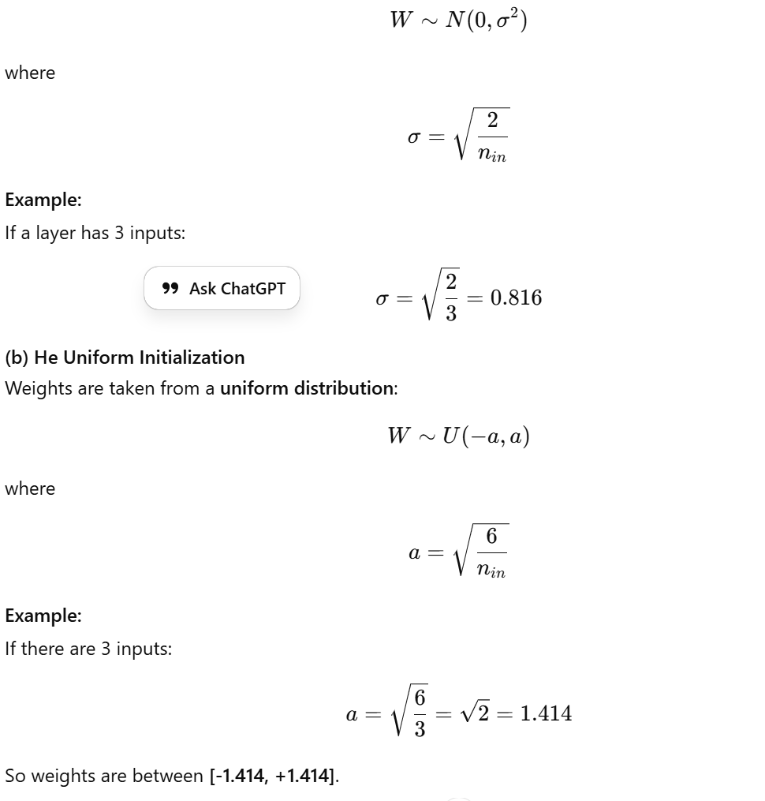

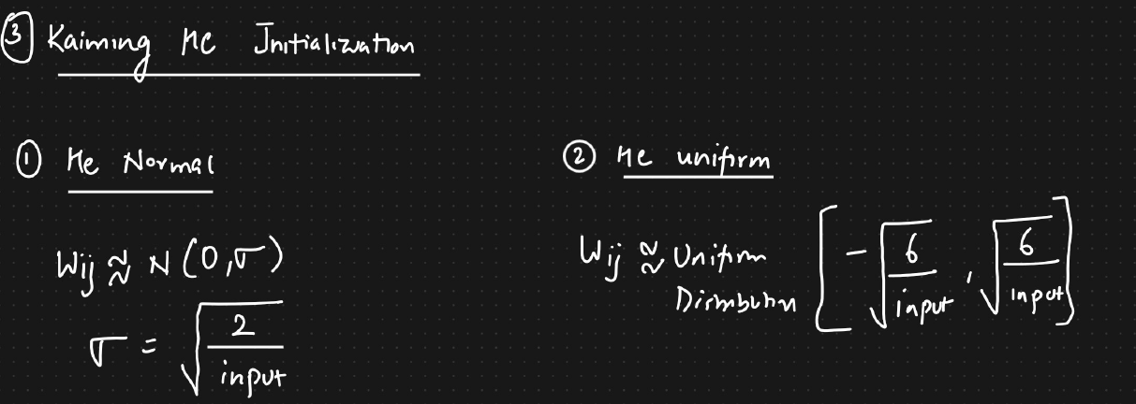

**Why it’s effective:**  
He Initialization maintains activation variance in deeper layers when using **ReLU**, helping gradients remain stable and preventing dead neurons.

| **Initialization Type** | **Distribution Used** | **Formula / Range** | **Best For** |
| --- | --- | --- | --- |
| **Uniform Distribution** | Uniform | ([-1/\sqrt{n_{in}}, 1/\sqrt{n_{in}}]) | Basic models |
| **Xavier Normal** | Normal (mean=0, std=(\sqrt{2/(n_{in}+n_{out})})) | Balanced gradients | Sigmoid / Tanh |
| **Xavier Uniform** | Uniform (([-√6/(n_{in}+n_{out}), √6/(n_{in}+n_{out})])) | Balanced updates | Sigmoid / Tanh |
| **He Normal** | Normal (mean=0, std=(\sqrt{2/n_{in}})) | Strong gradients | ReLU / Leaky ReLU |
| **He Uniform** | Uniform (([-√6/n_{in}, √6/n_{in}])) | Robust initialization | ReLU family |

**368 Drop out layers:**

**What Is Overfitting?**

Before understanding dropout, it’s important to know **why** we use it.  
Overfitting happens when a model learns the **training data too well** — it memorizes patterns instead of generalizing.

**Example:**

* Training accuracy = 90%
* Test accuracy = 60%

This means the model performs very well on the data it has seen (training data) but poorly on new data (test data).  
Such a model has **overfitted**.

**🔍 Key reason for overfitting:**

* Model has **too many parameters (weights and biases)**.
* Learns **every small pattern and noise** from the training data.
* Fails to generalize for unseen data.

**What Is Dropout Layer?**

The **Dropout Layer** is a **regularization technique** used in deep learning to **reduce overfitting**.  
It works by **randomly deactivating (dropping)** some neurons during training.

In simple words:

“During each training pass, dropout switches off some neurons at random so that the network doesn’t become too dependent on certain paths or nodes.”

**4️ How Dropout Works (Concept)**

Let’s say you have a neural network with:

* Input Layer
* Hidden Layer 1
* Hidden Layer 2
* Output Layer

In a normal network:

* Every neuron is connected to every neuron in the next layer.
* Every connection has a weight.

This creates many connections and **a high risk of overfitting**.

In a **dropout network:**

* Random neurons are “dropped out” (ignored) during training.
* This means those neurons and their connections are temporarily removed.

So, in each training pass (iteration):

* Different sets of neurons are active.
* The network learns multiple independent representations.
* This makes the model more robust and general.

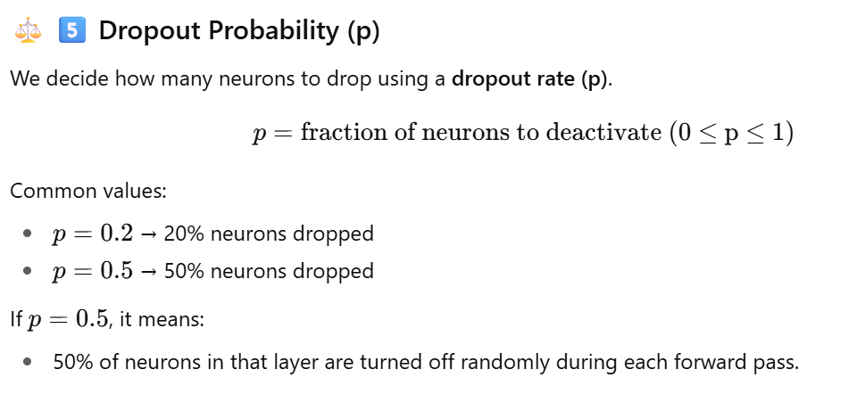

**Dropout During Forward and Backward Propagation**

**Forward Propagation:**

* Dropout deactivates neurons based on probability ppp.
* Only active neurons participate in forward pass.

**Backward Propagation:**

* Gradients are computed only for **active neurons**.
* Inactive neurons don’t get updated in that iteration.

Thus, during each training pass, only a **subset of weights** are updated.

**🧠 9️. What Happens During Testing (Inference)?**

During testing or prediction:

* We **do not apply dropout** — all neurons are active.
* Because during inference, we want the **full power** of the network to make predictions.

However, since dropout reduced the number of active neurons during training,  
we must **scale the weights** during testing to balance their effect.

**How?**

Multiply the weights by the same **dropout probability (p)** that was used during training.

Example:

* If p=0.5p = 0.5p=0.5, multiply all test-time weights by 0.5.
* This ensures the expected output during testing is similar to training.

**⚙️ 10️ Comparison: Training vs Testing Phase**

| **Phase** | **What Happens** | **Effect** |
| --- | --- | --- |
| **Training** | Random neurons are deactivated using dropout rate ppp. | Helps prevent overfitting and forces generalization. |
| **Testing** | No neurons are deactivated; all are active. | Ensures full capacity is used for prediction. |
| **Adjustment** | Multiply all weights by ppp | Keeps outputs consistent with training behavior. |

**🎯 11️ . Why Dropout Works (Intuition)**

Dropout works by making the network **less sensitive to small variations** in the input or hidden layers.

In other words:

* It forces neurons to learn **independent and redundant representations**.
* It acts like training **many smaller sub-networks** that share weights.
* The final model behaves like an **ensemble average** of many models → more stable and generalized.

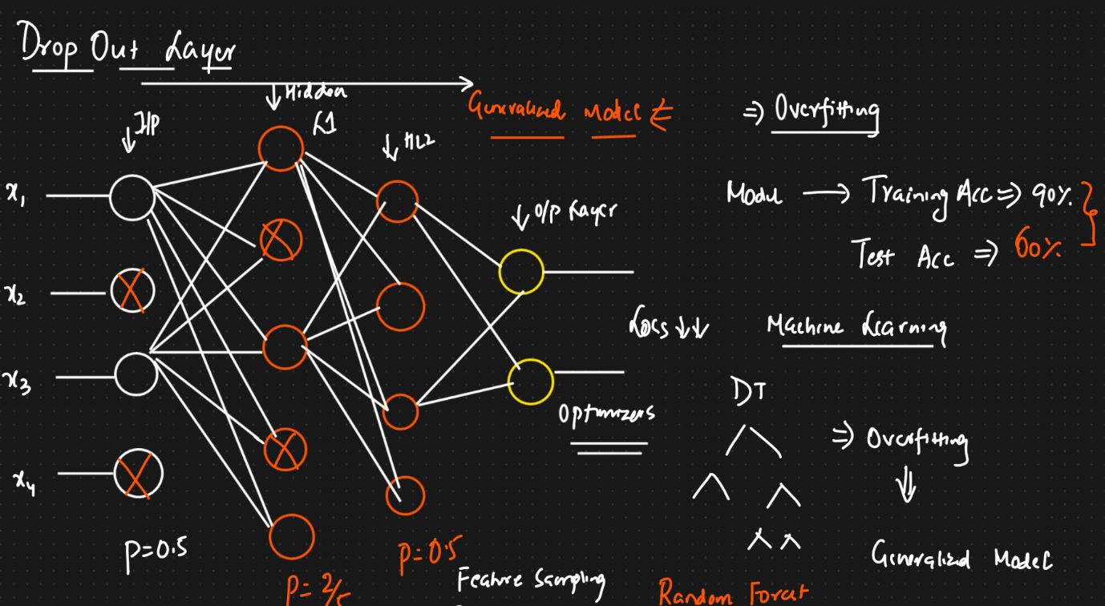

**📊 12️ . Dropout vs Random Forest Analogy**

The instructor in your transcript compared dropout to **Random Forest** in machine learning.

| **Technique** | **Mechanism** | **Purpose** |
| --- | --- | --- |
| **Random Forest** | Uses **subset of features and data rows** in each tree. | Reduces overfitting in decision trees. |
| **Dropout** | Uses **subset of neurons and connections** in each training pass. | Reduces overfitting in neural networks. |

So, dropout = feature/connection sampling for neural networks (li

**TensorFlow**

**🔹 Main Tools Used**

1. **TensorFlow**
   * An open-source library for deep learning.
   * Supports building and training neural networks (ANN, RNN, LSTM, GRU, Transformers, etc.).
   * Suitable for end-to-end AI projects — from model training to deployment.
2. **Keras**
   * Acts as a **high-level API (wrapper)** on top of TensorFlow.
   * Makes neural network creation easier — fewer lines of code, more readable.
   * Integrated into TensorFlow (no need for separate installation now).

👉 **Note:** Keras also supports PyTorch and JAX, but this course uses TensorFlow.

Below are the sequence of steps we will be using while creating DL pipeline using TensorFlow

* 1. We need to start sequential network
  2. Dense 🡪 To create a hidden neuron
  3. Activation function
  4. Optimizers ( used in back propagation in updating weights)
  5. Loss function
  6. Metrics ( Classification 🡪 Accuracy , Regression 🡪 MSE,MAE,RMSE )
  7. In Training we store logs /p

Model = Sequential ([

Dense(64,activation=’relu’,input_shape=(X_train.shape(1),)), ## HL1

Dense(32, activation=’relu’), ## HL2

Dense(1, activation=sigmod) ## Output layer

]

)

Model.summary()

Opt = tensorflow.keras.optimizers.Adam(learning_rate=0.01)

Model.complier(optimizer=”adam”,loss=”binary_classifcation”,metric=[“acuuracy”])

When we train neural networks, we can train it for ‘n’ of epochs and there might cases after certain no.of epochs the loss value is not decreasing and in this scenarios we can use Early stopping.

aja